**AWS PROJECT**

**STEP1: TO CREATE An ACM (AWS CERTIFICATE MANAGER)**

**TO HOST THE APPLICATION SECURELY (WE NEED A CERTIFICATE MANAGER) – LISCENCE.**

**We get the certificate from ACM.**

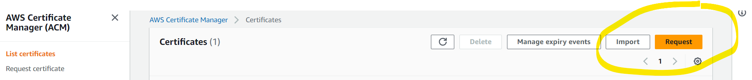

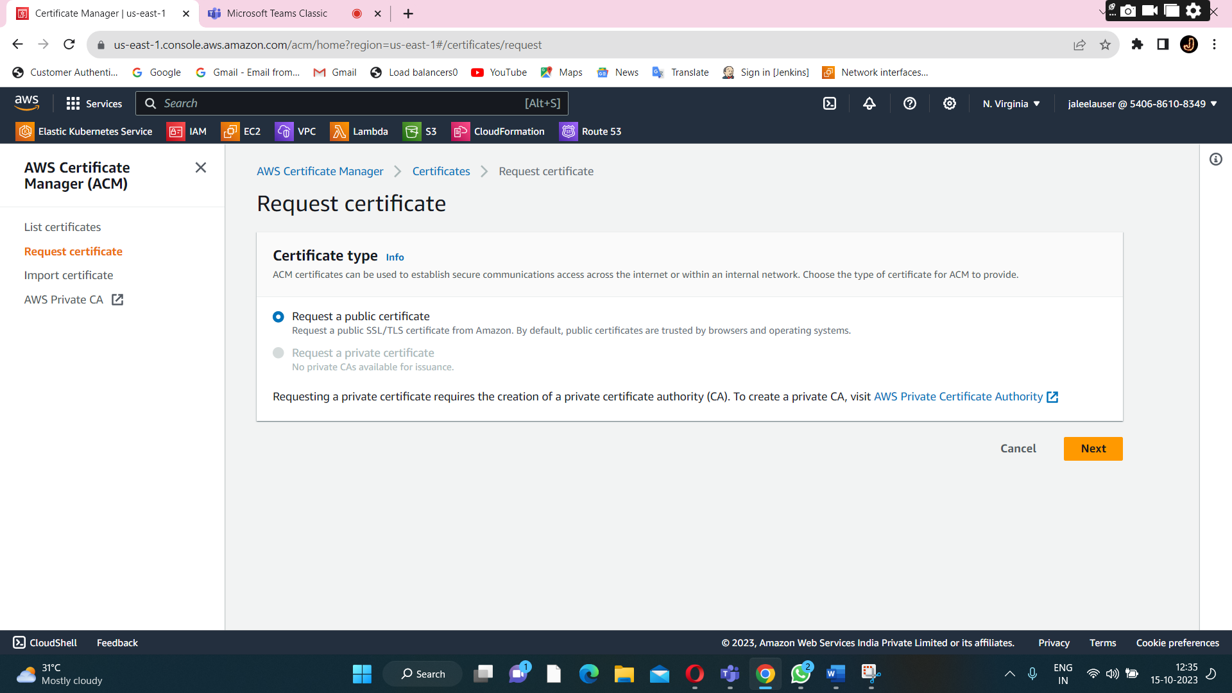

**Click on request**

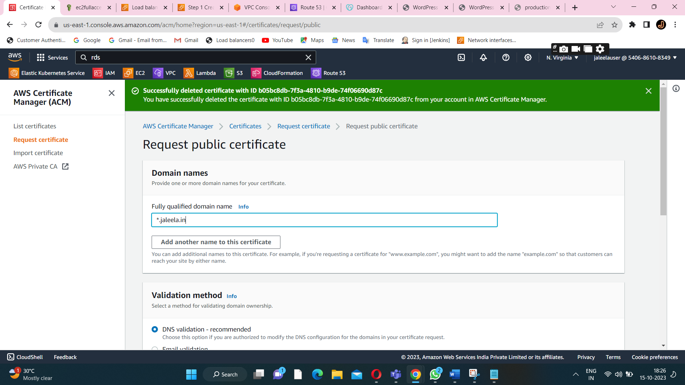

**Create a domain for a application.**

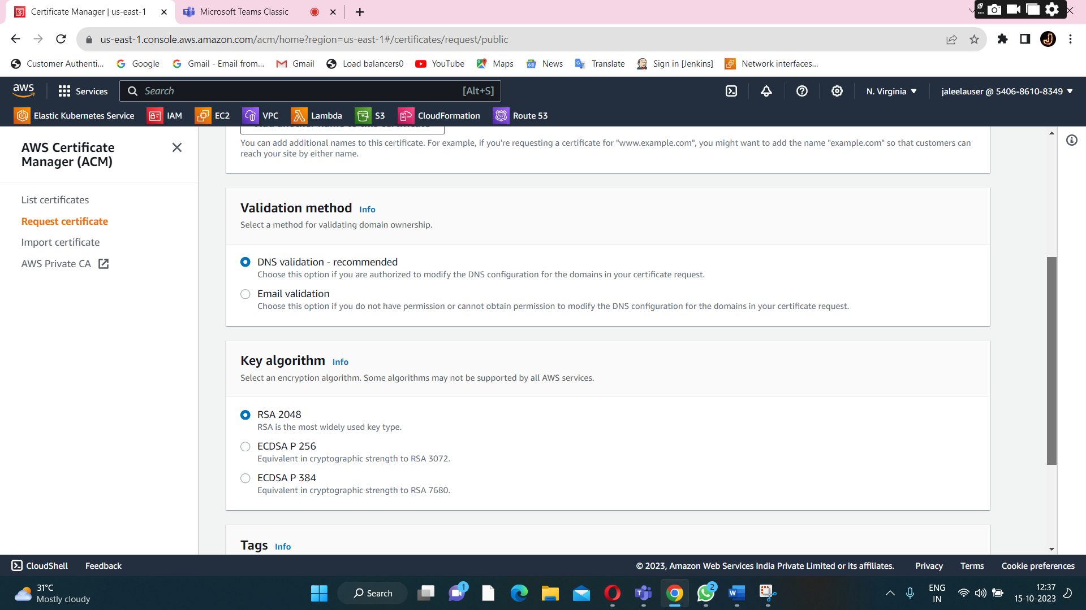

**Choose the dns validation and key algorithm.**

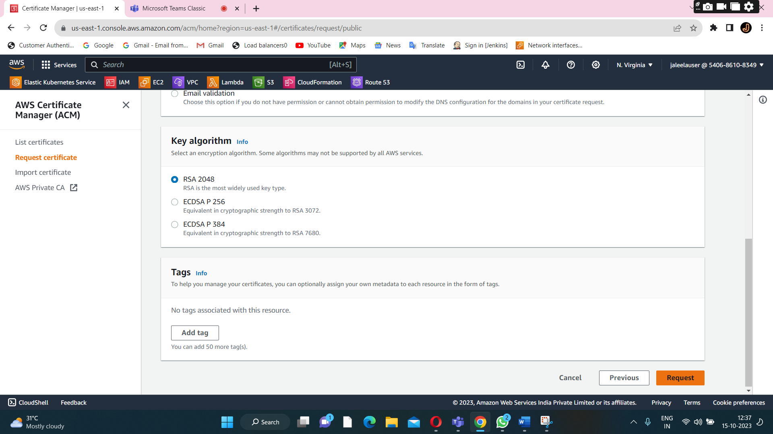

**Click on request for a certificate.**

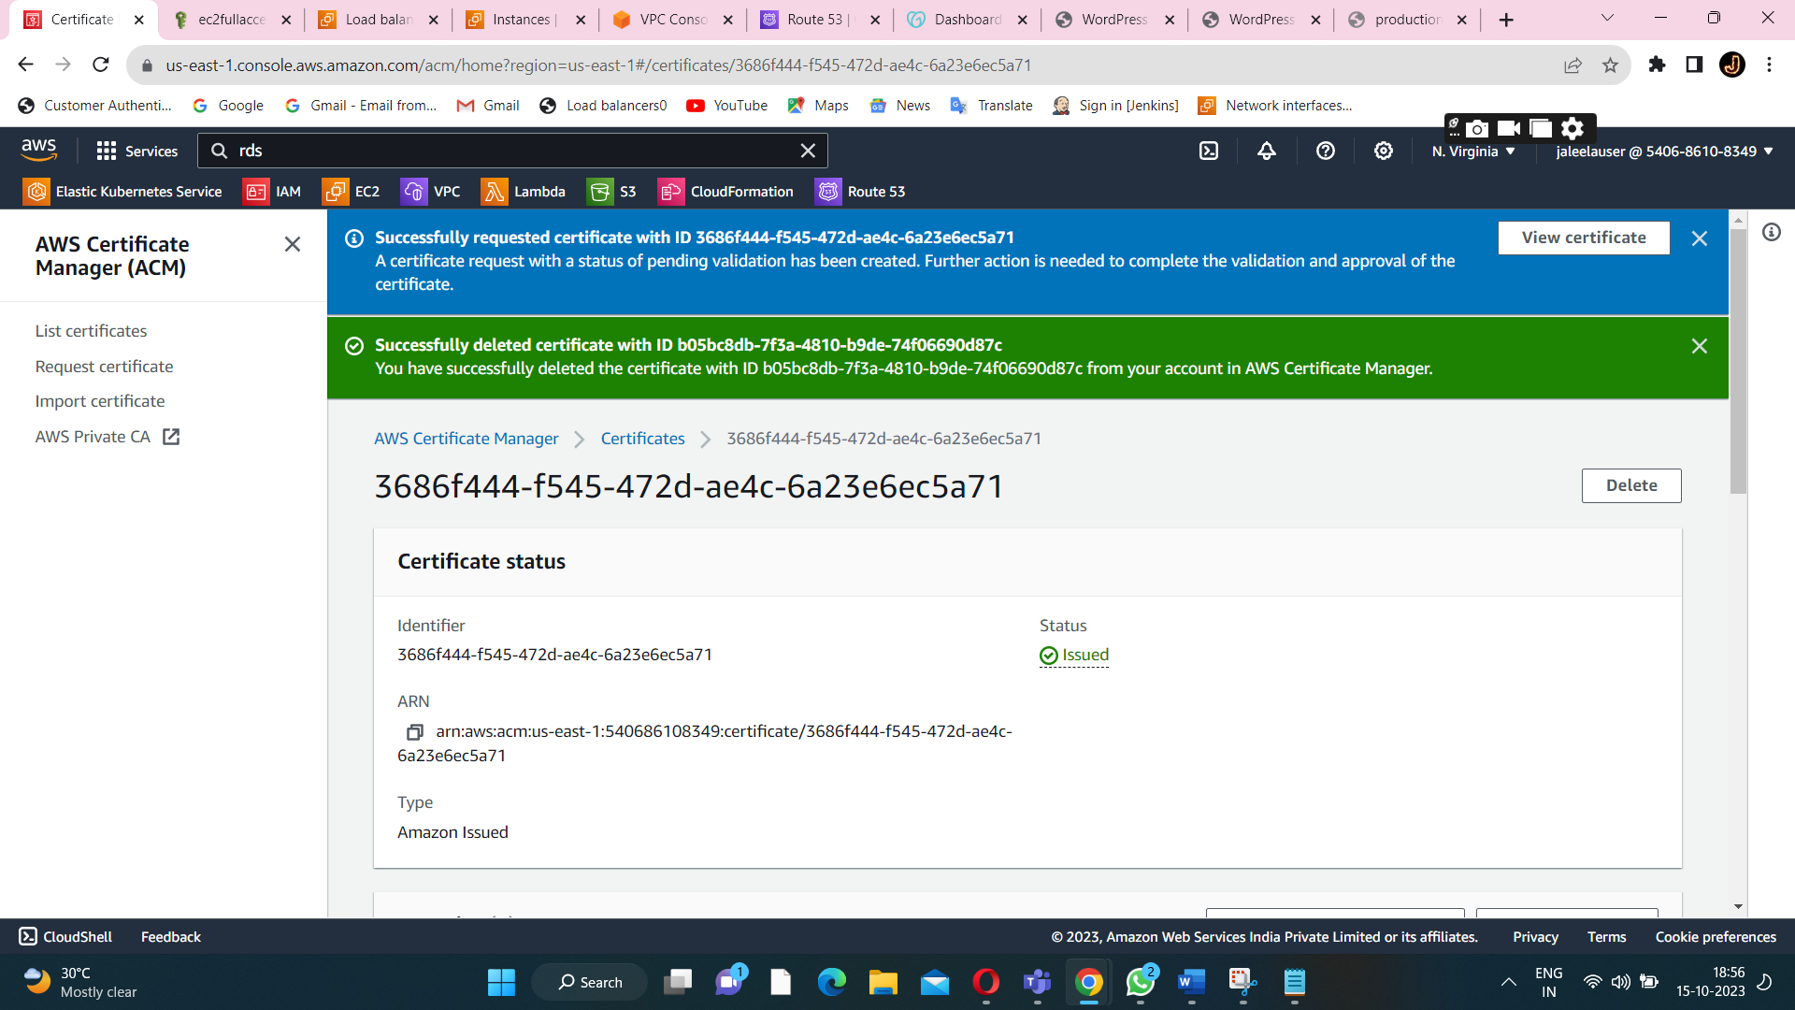

**Certificate is created successfully.**

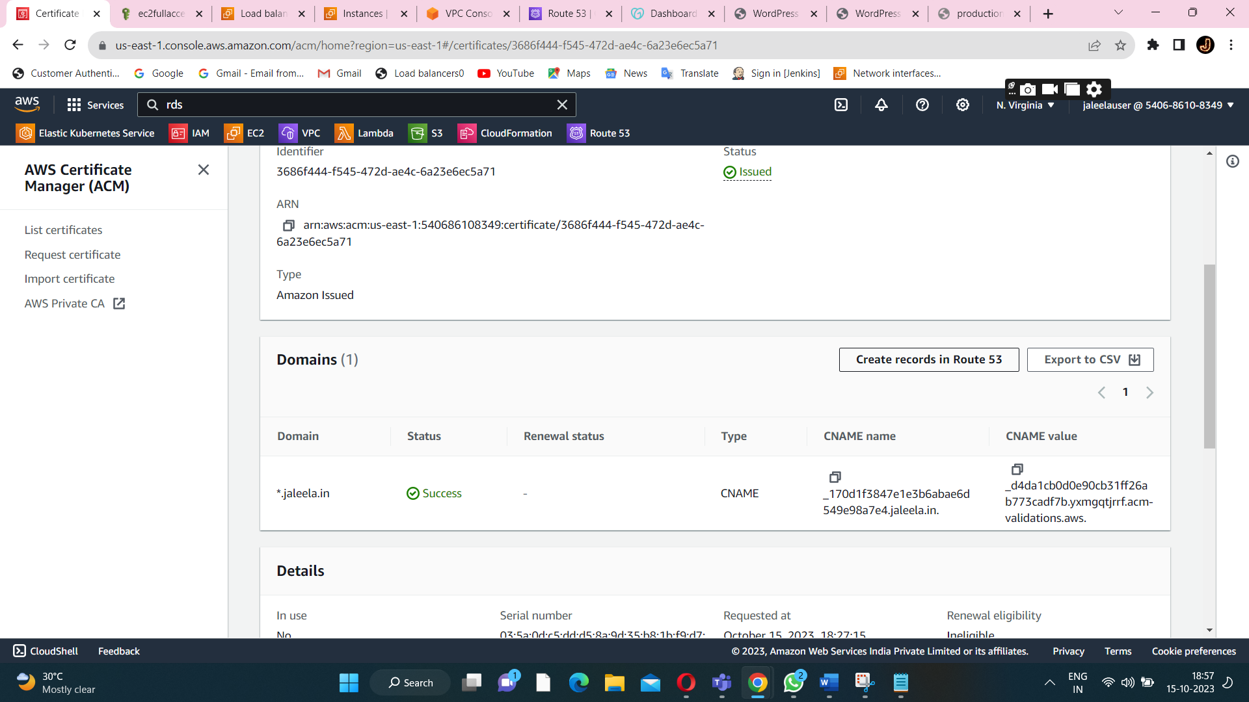

**After certificate manager is created successfully,then I create a record in a Route53.**

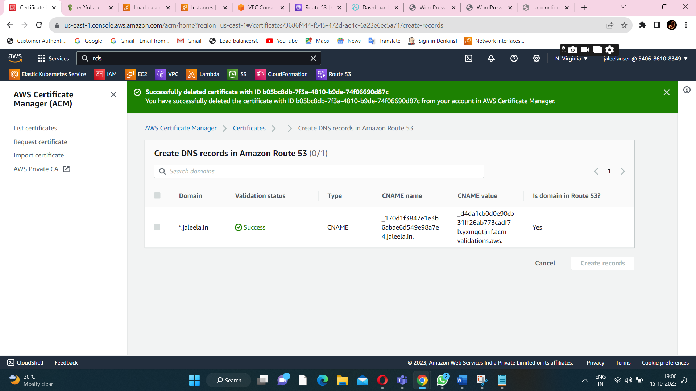

**Already this domain in route53.**

**STEP2:create a route53**

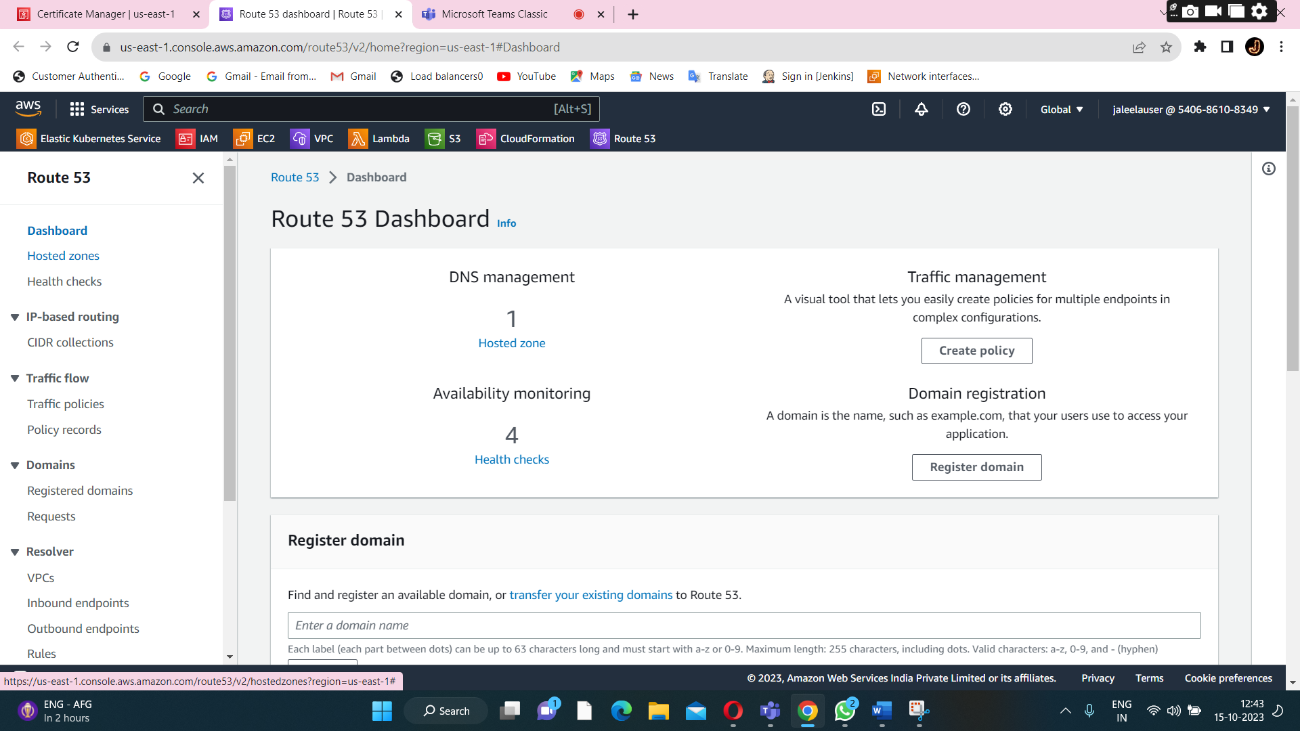

**Click on a hosted zone.**

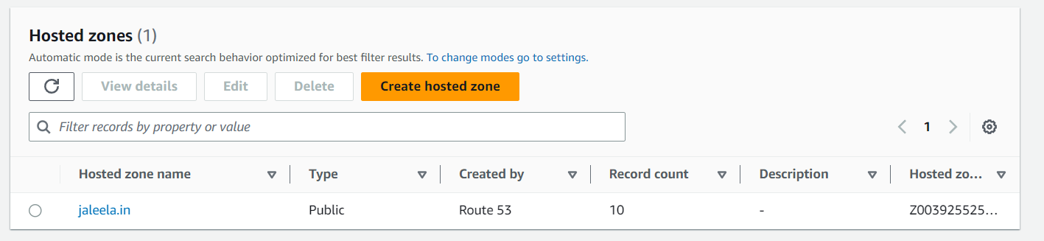

**Hosted zone is created.**

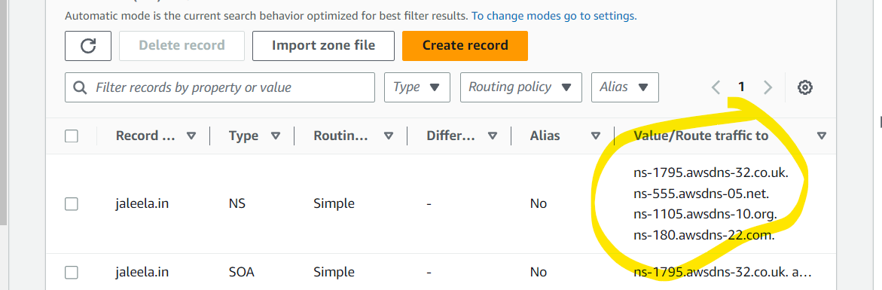

**To attach the nameserver from a godaddy domain. Domain is available in a ROUTE53.So we will create record inside the domain name based on the application.**

**STEP3:CREATE AN RDS INSTANCE**

**Create a subnet for a db instance(for high availability)**

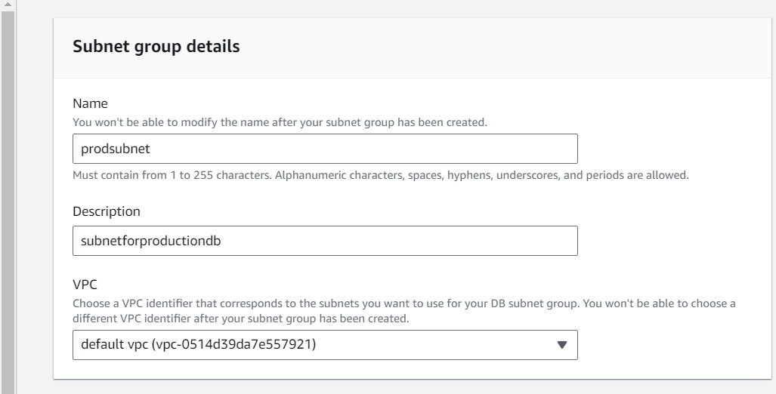

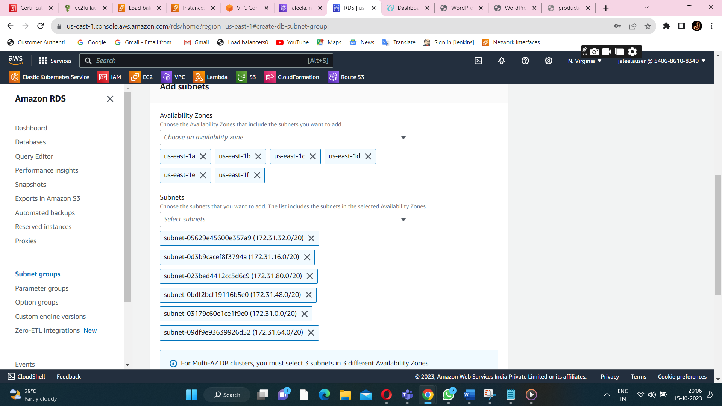

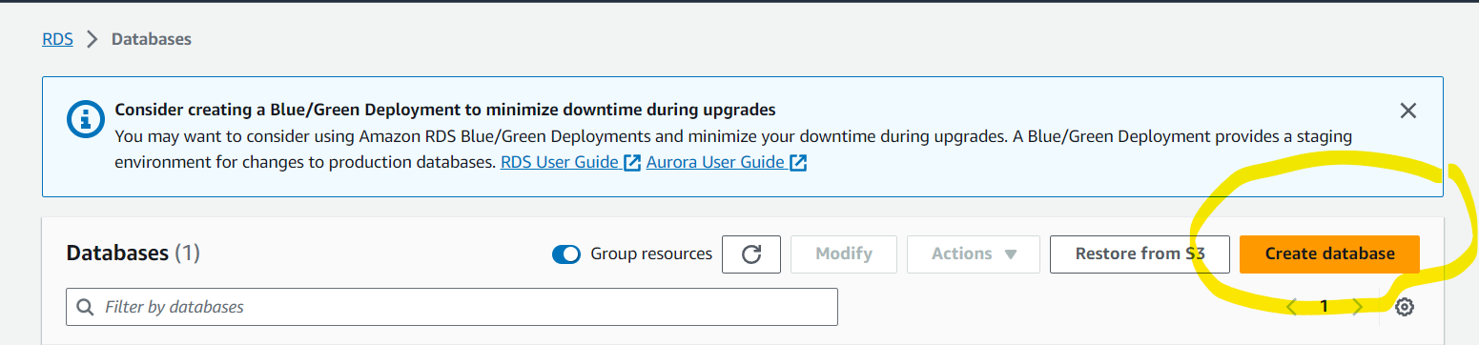

**Create a database.**

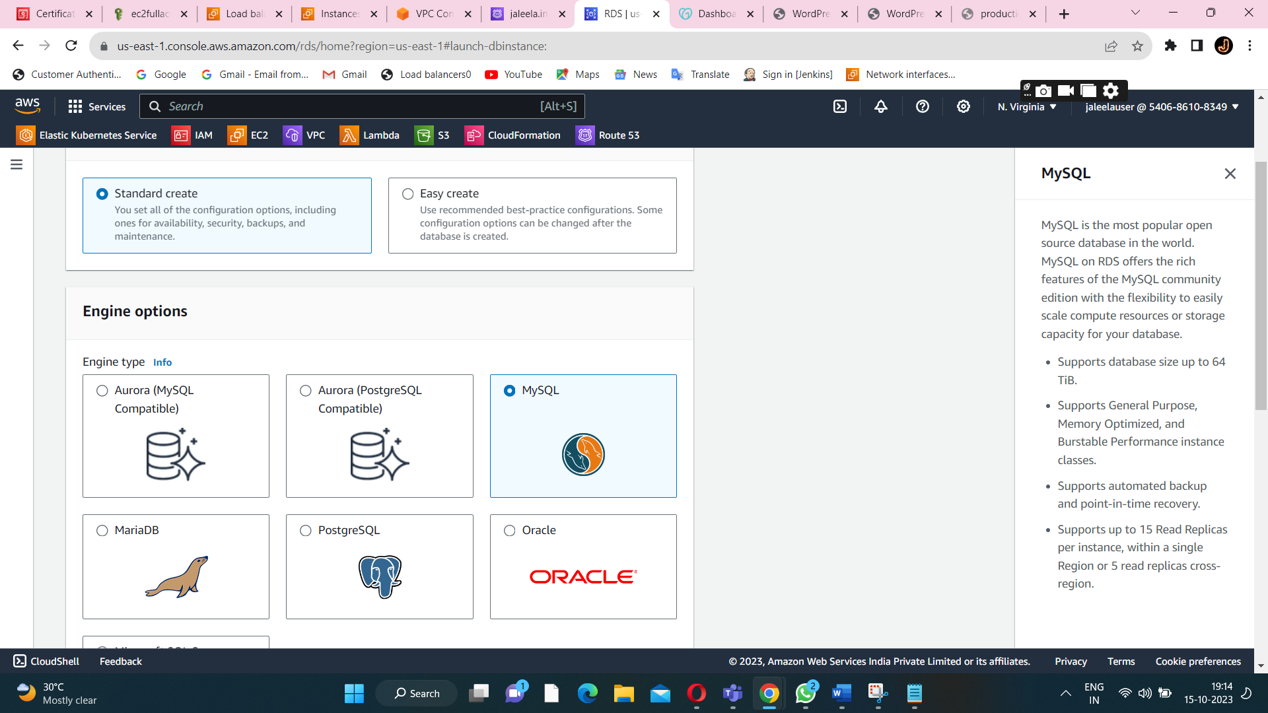

**Choose the dbengine-MySql.**

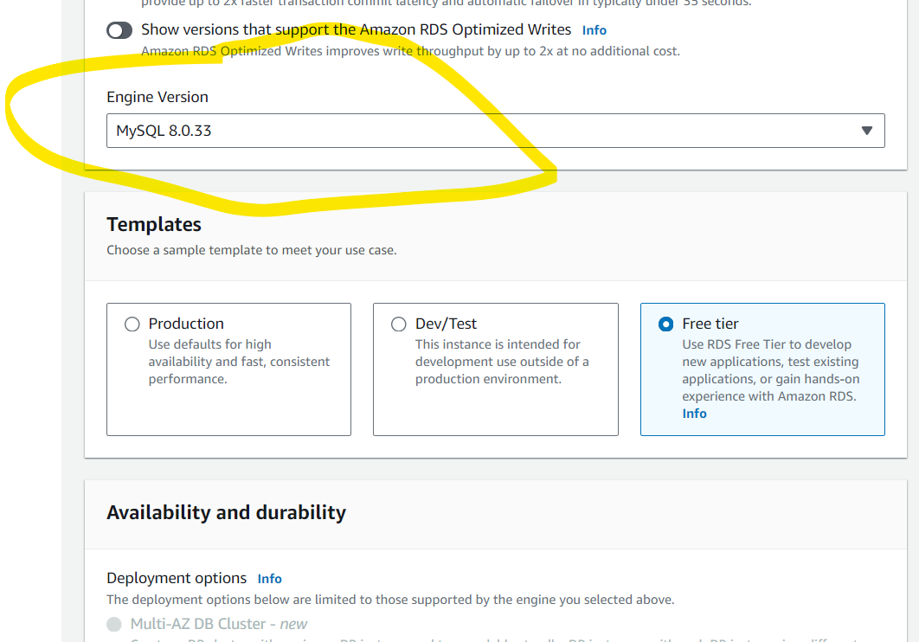

**Choose the mysql latest version.**

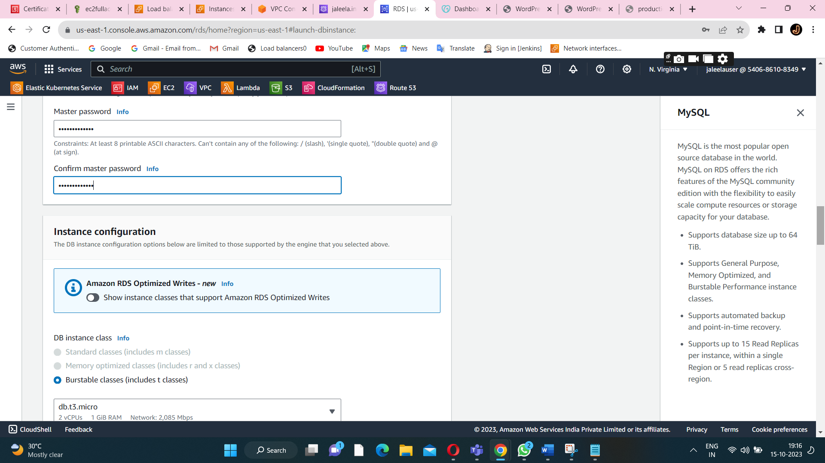

**Create a security group for RDS database.**

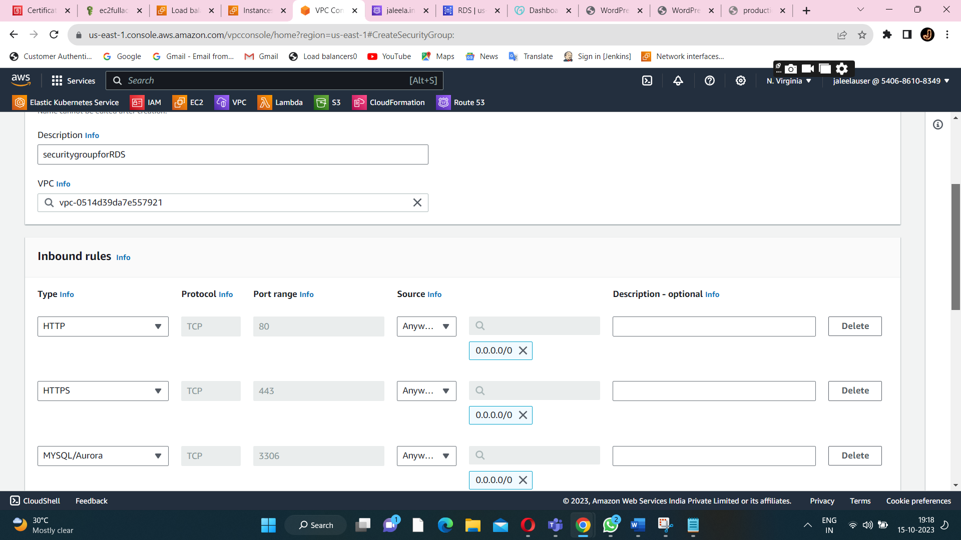

**Inbound rule for a securitygroup.**

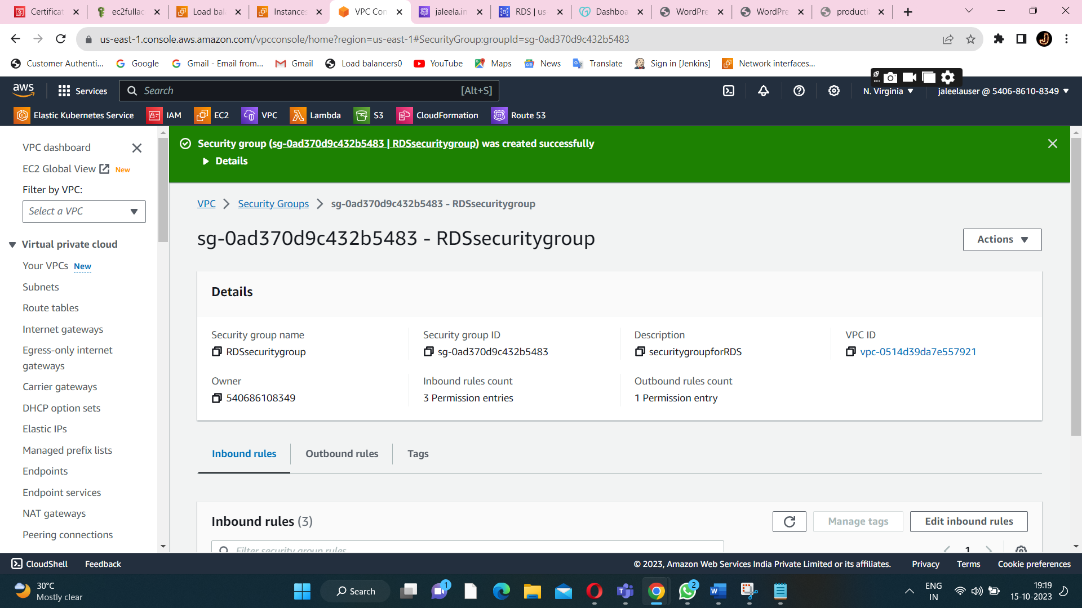

**SecuritygroupforRDS is created successfully.**

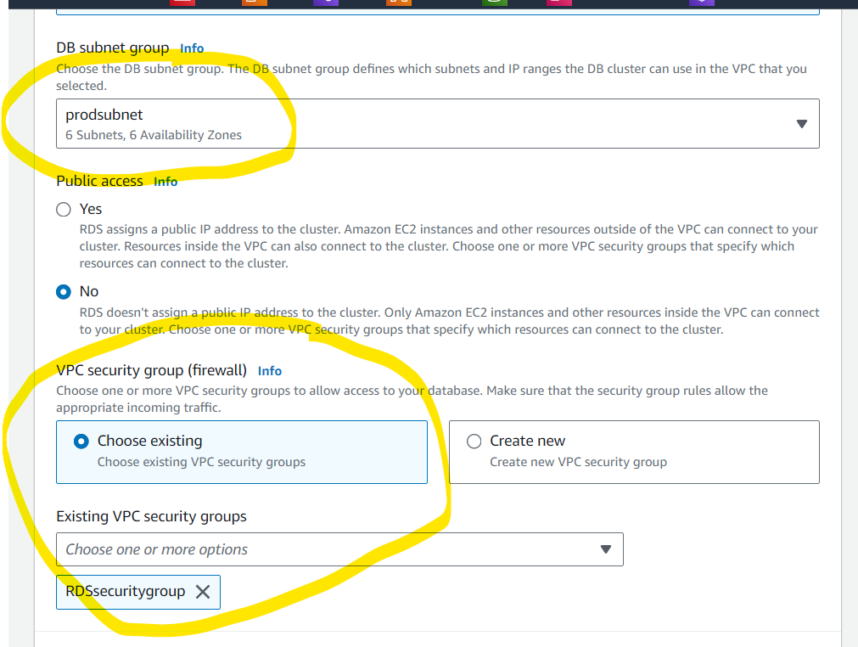

**Assign all the configurations for a db instance.**

**Do the same configuration for a disaster db instance.**



**Prod db is created successfully.(along with a required subnet,security group,db name and VPC).**



**Disaster db is created successfully.**

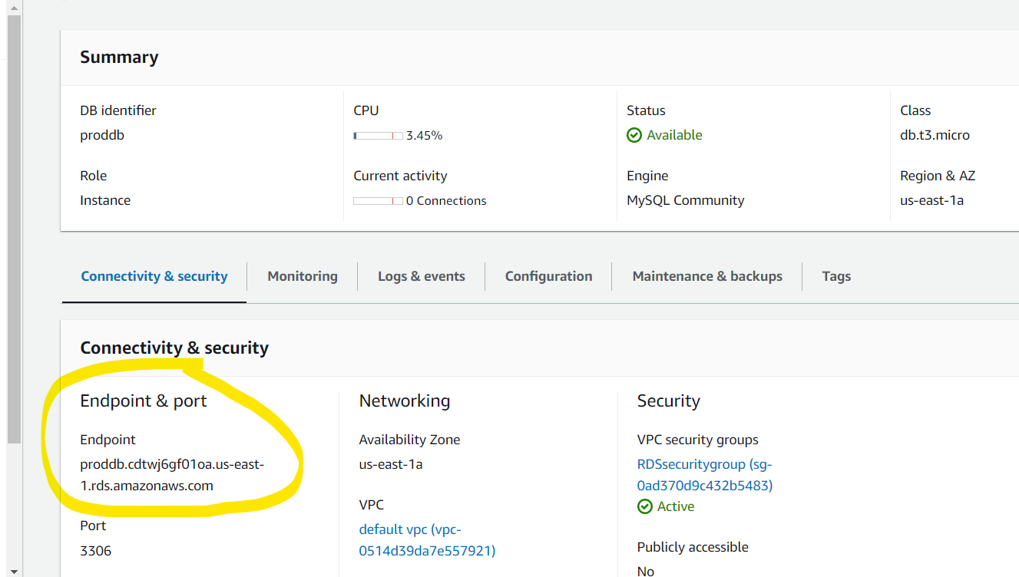

**Inside the db endpoints are available(for connecting ec2 to RDS(db instance)).**

**STEP4:CREATE AN IAM ROLE.**

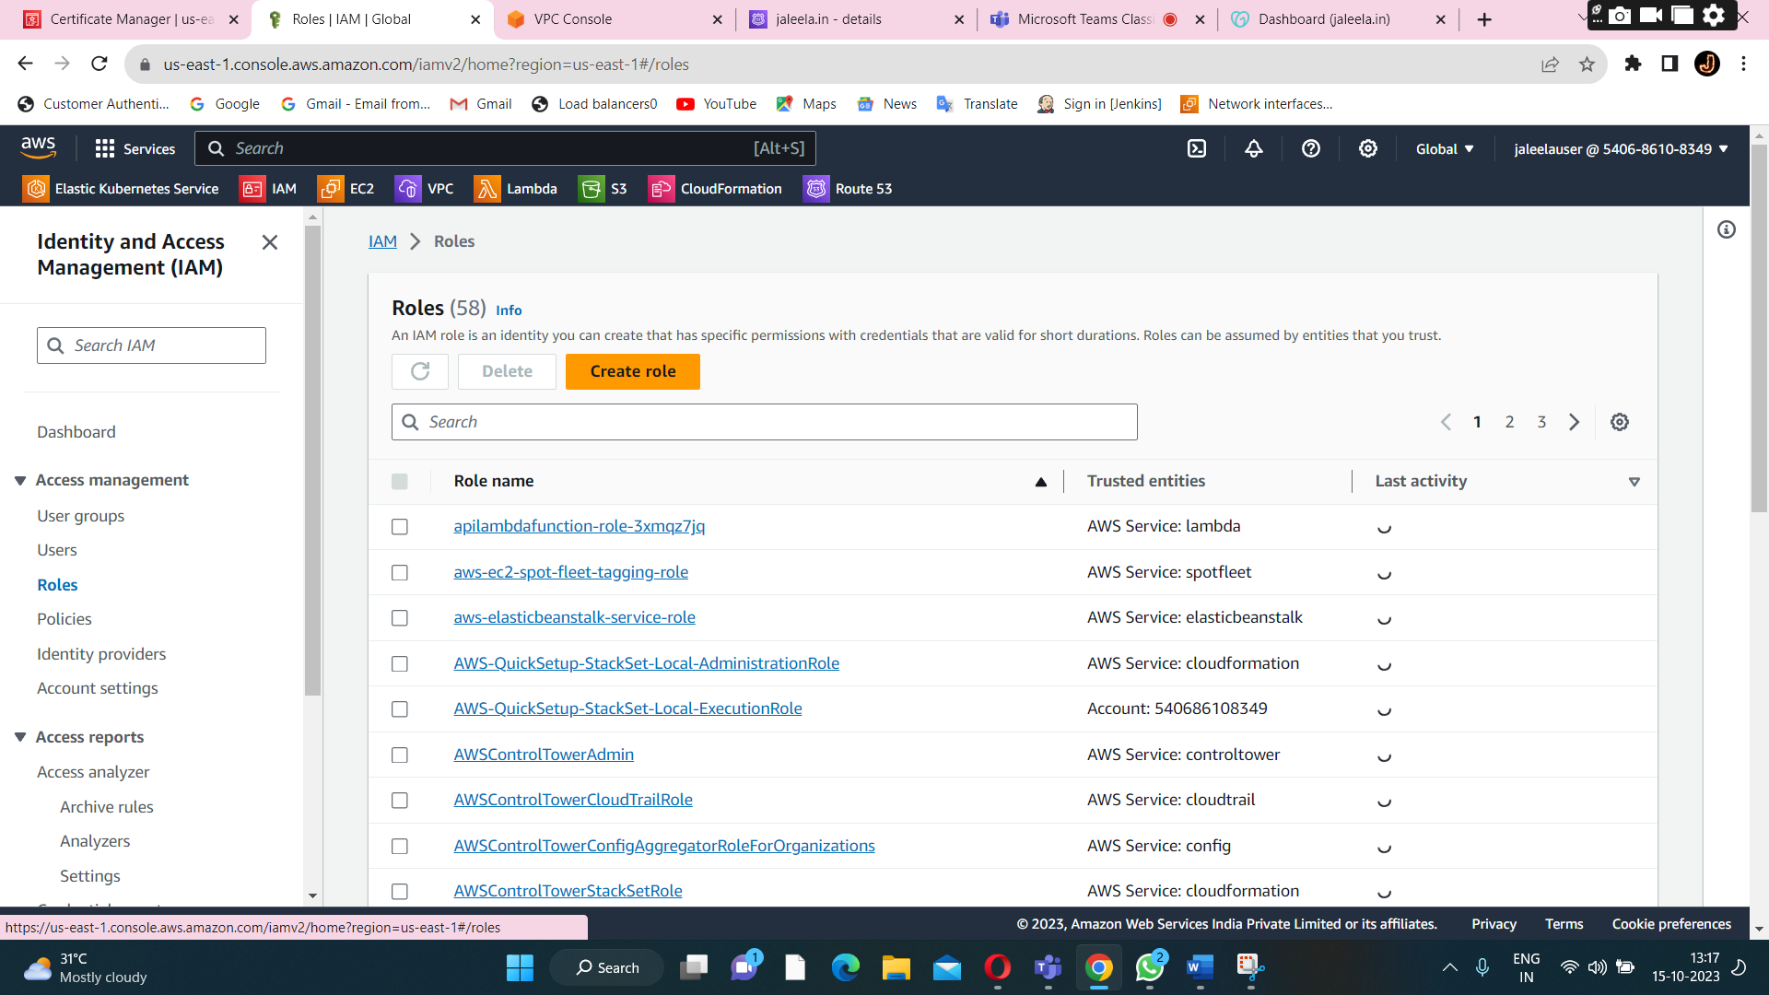

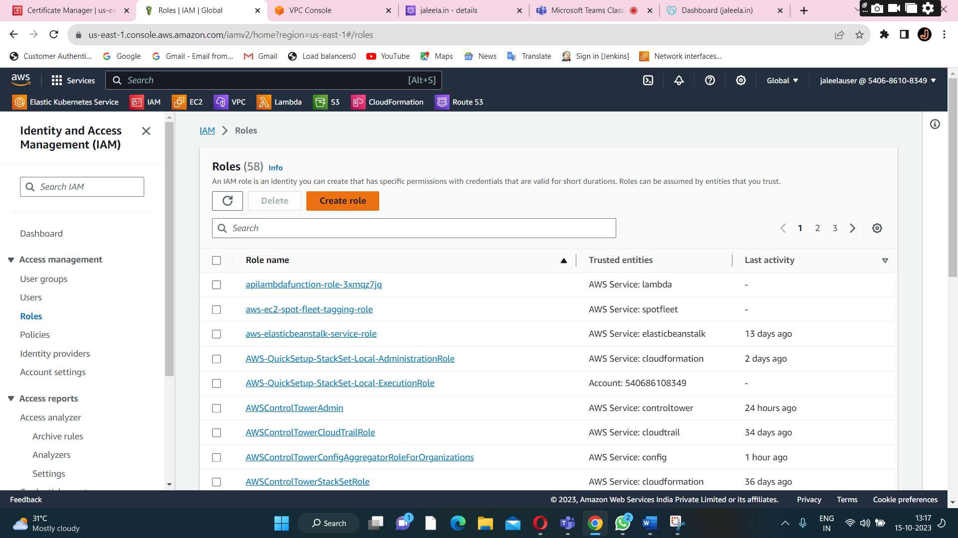

**Click on create role.**

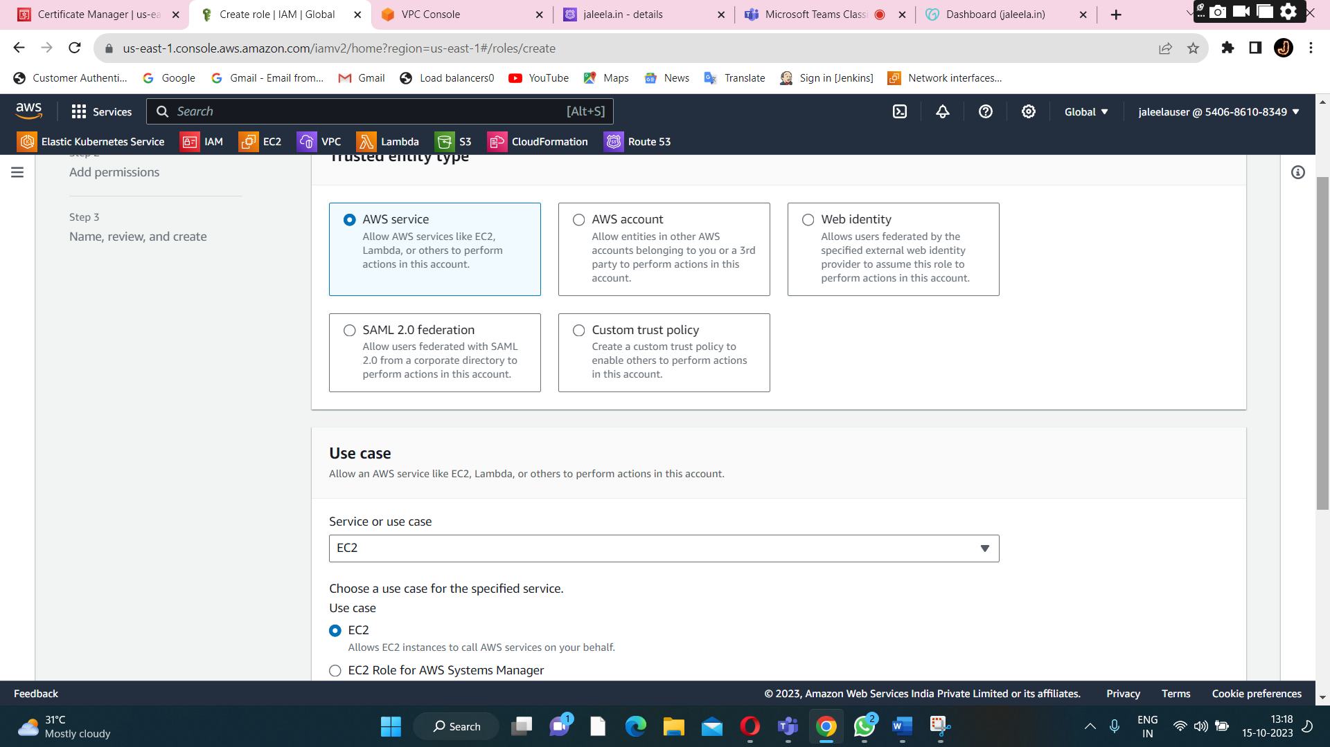

**To choose the EC2 service.**

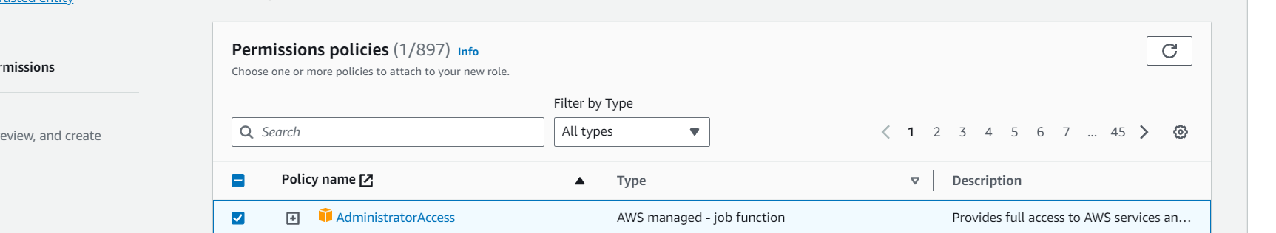

**To give a full admin access to a ec2 instance.**

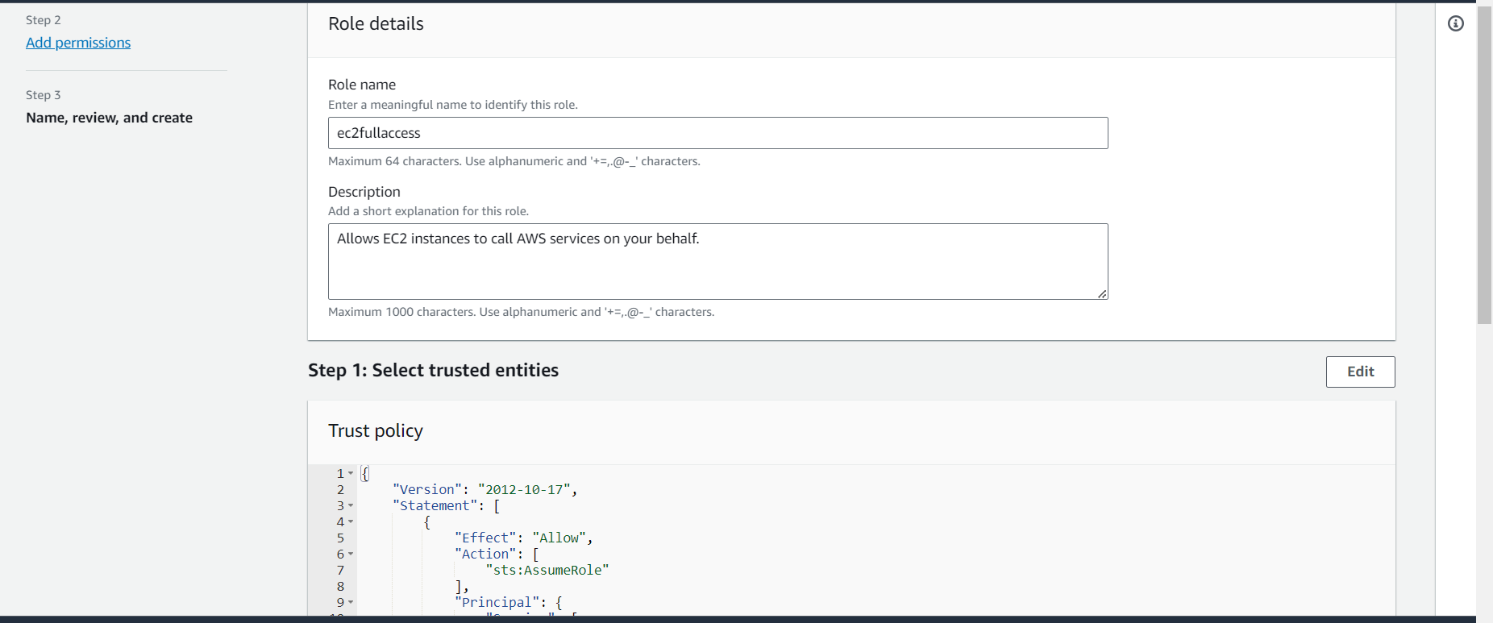

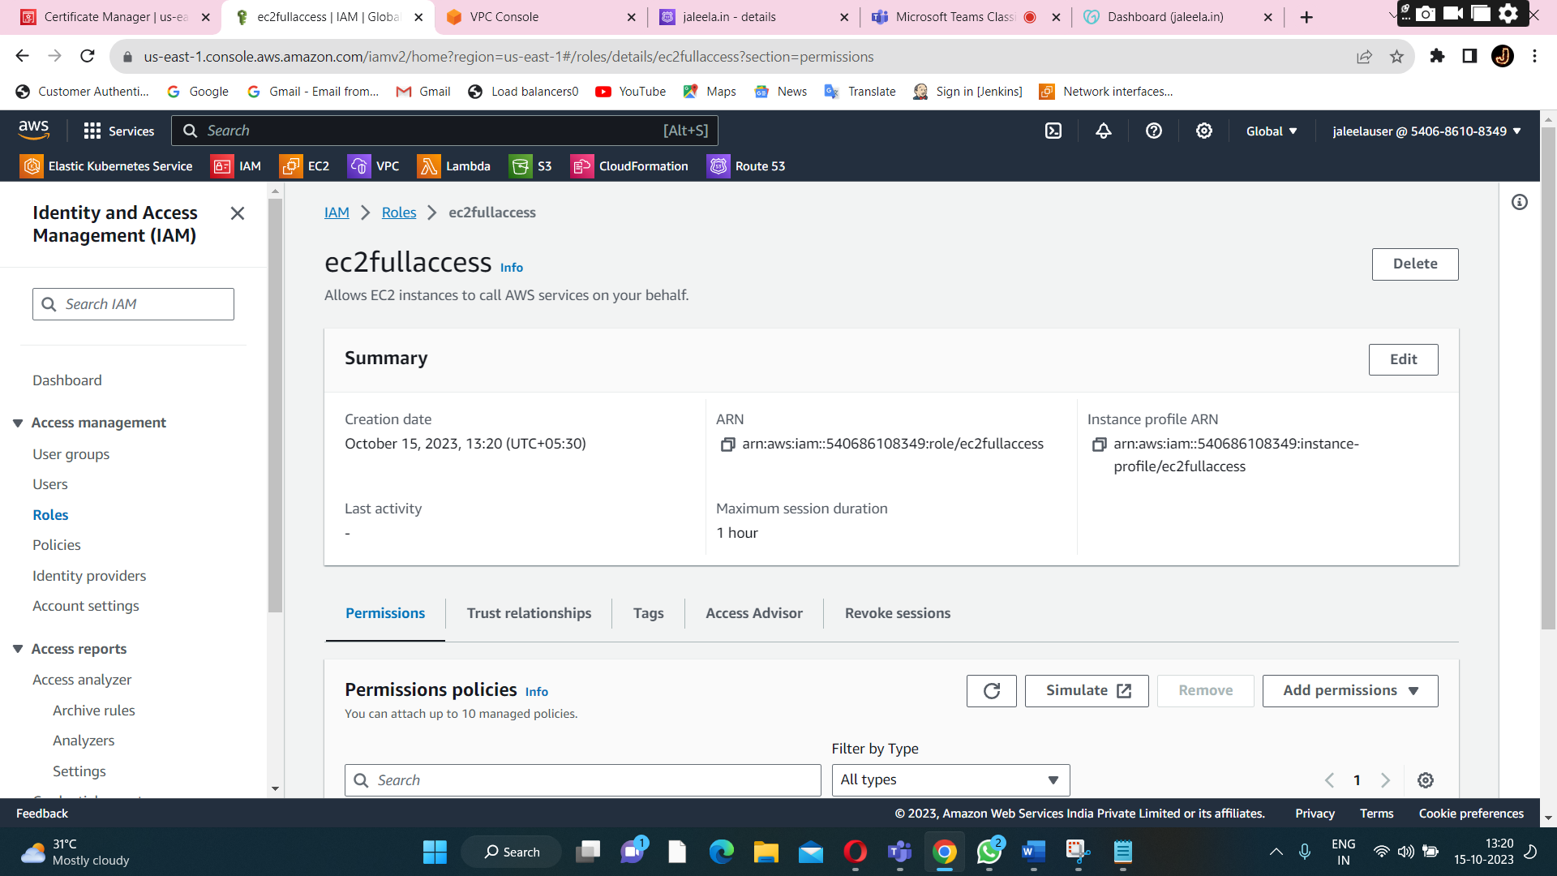

**Role is created for full access to a ec2 service.**

**STEP5:EC2 INSTANCE CREATION**

**Two launch the two instances for production and disaster recovery.**

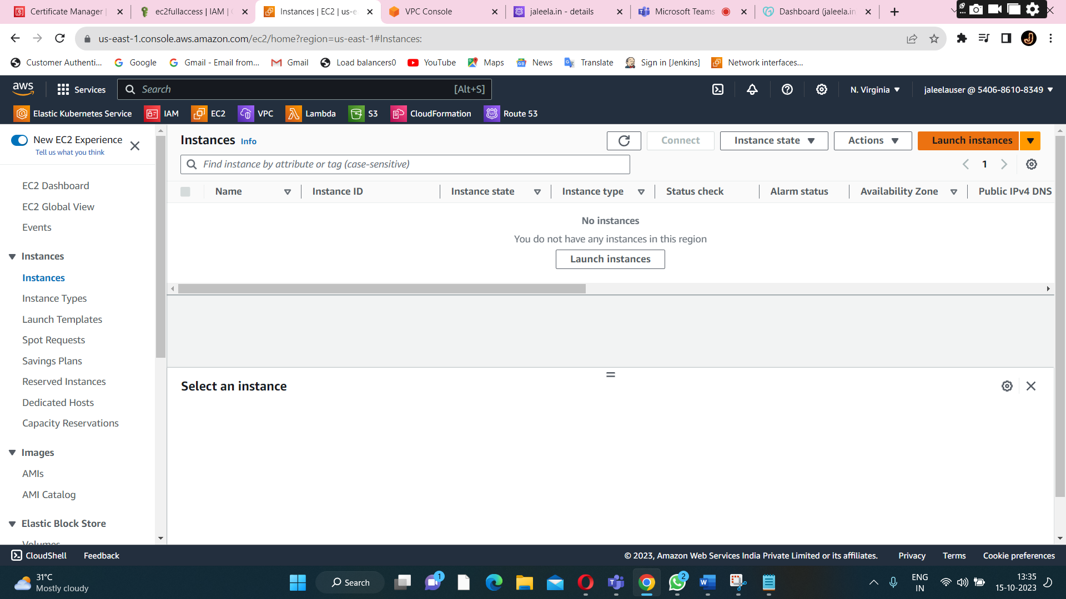

**Launch the instance.**

**To create a security group for ec2-instance.**

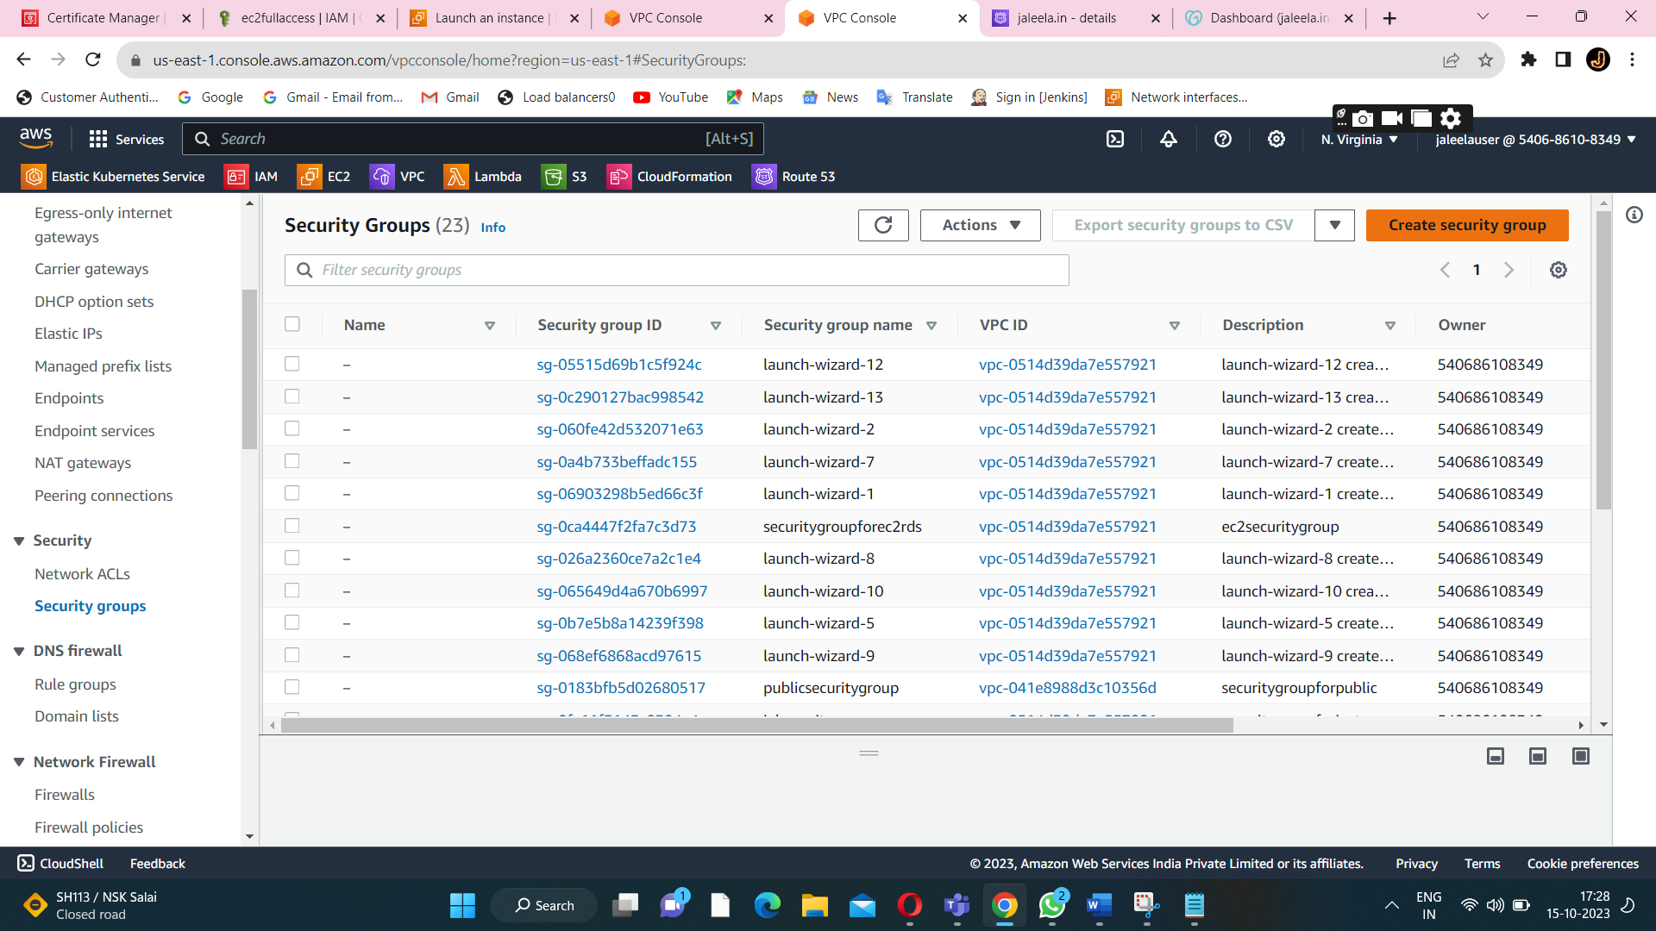

**Click on security group.**

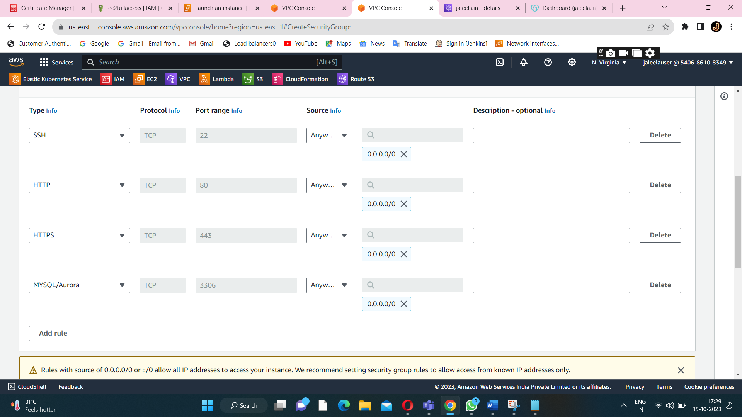

**Inbound rules for ec2 security group.**

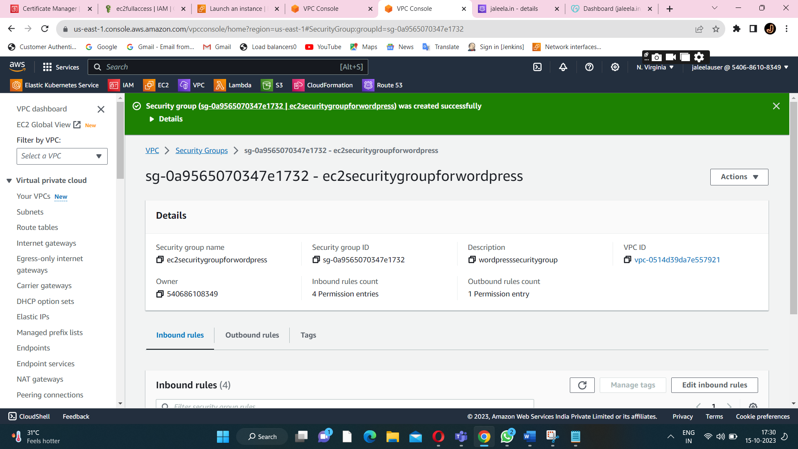

**Security group is created successfully.Now I launch the instance.**

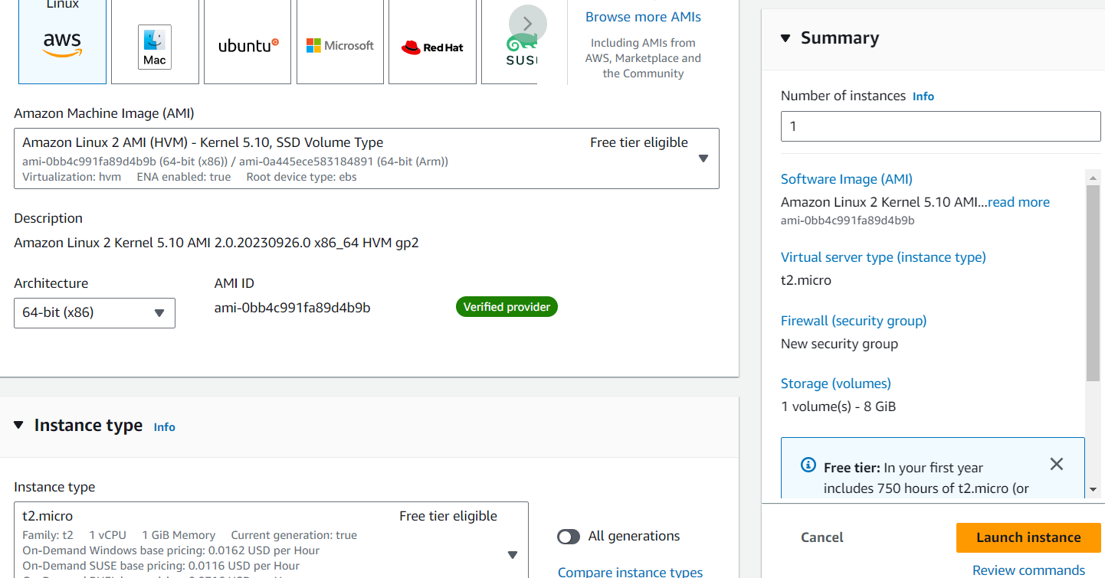

**Choose the linux os,ami,instance type.**

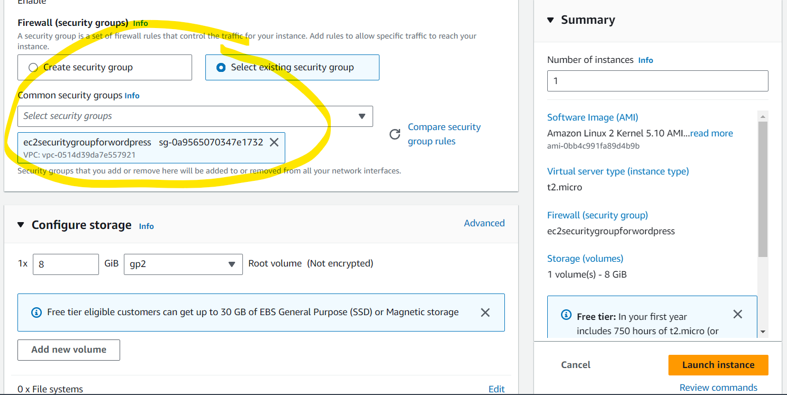

**Attach the security group,that we had created.**

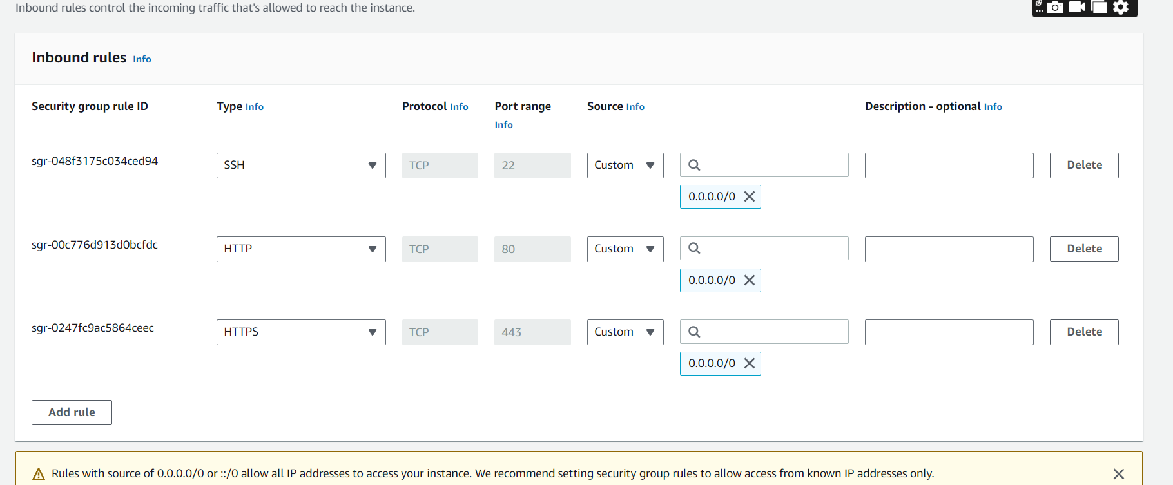

**Inbound rule of the security group of the instances.(ssh,http,https).**

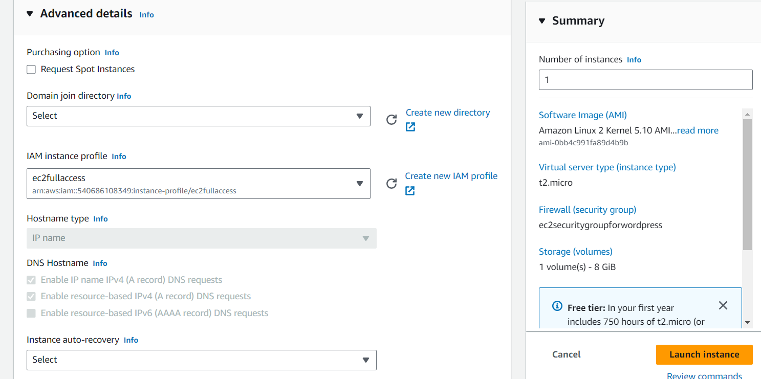

**To attach the ec2 full access IAM role to a ec2-server.**

#!/bin/bash

yum install httpd php-mysql -y

amazon-linux-extras install -y php7.3

cd /var/www/html

echo "healthy" > healthy.html

wget https://wordpress.org/latest.tar.gz

tar -xzf latest.tar.gz

cp -r wordpress/* /var/www/html/

rm -rf wordpress

rm -rf latest.tar.gz

chmod -R 755 wp-content

chown -R apache:apache wp-content

wget https://s3.amazonaws.com/bucketforwordpresslab-donotdelete/htaccess.txt

mv htaccess.txt .htaccess

chkconfig httpd on

service httpd start

**attach the above Userdata.**

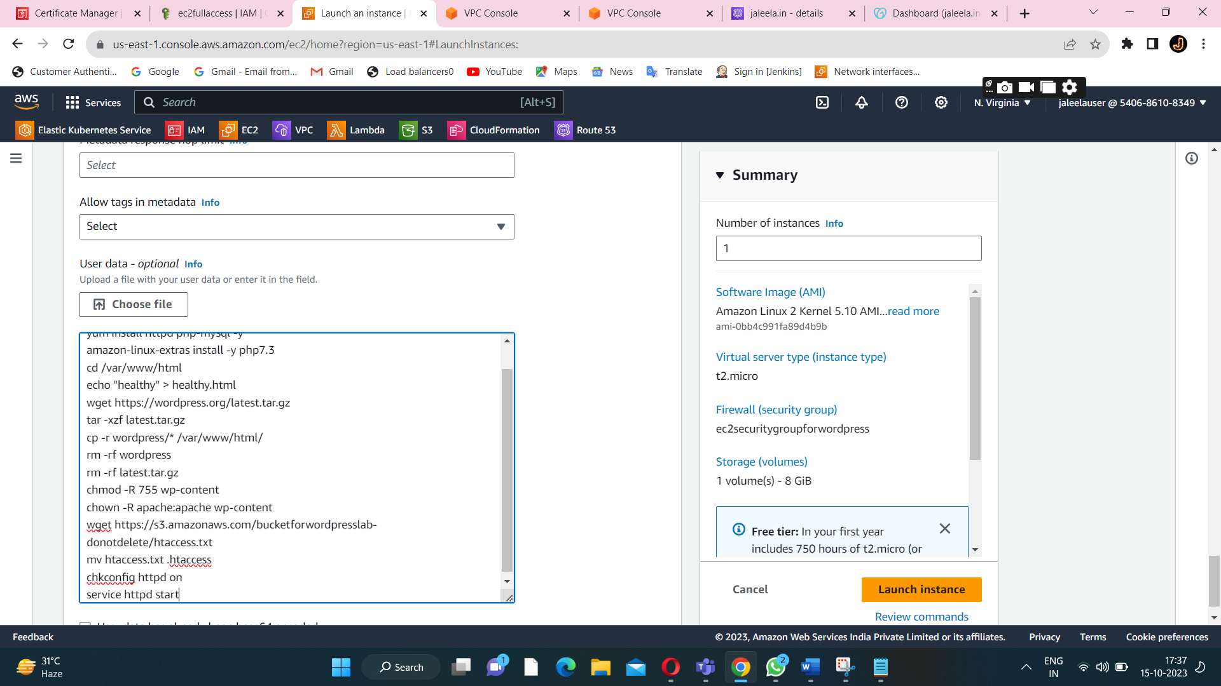

**Then launch 2 instances.**

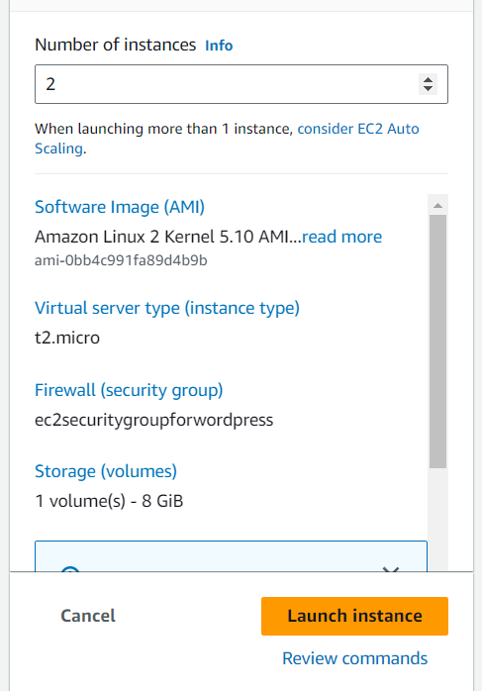

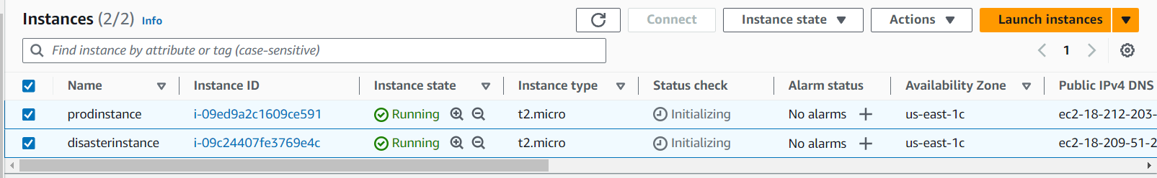

**Two instances is launched successfully.**

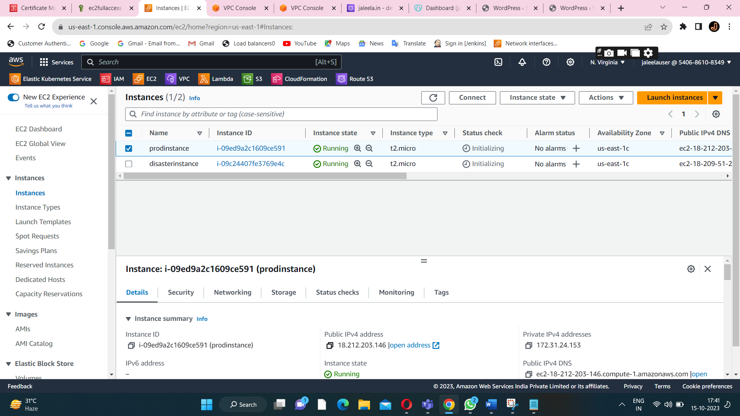

**Copy the public ip-address of a ec2-instnace.**

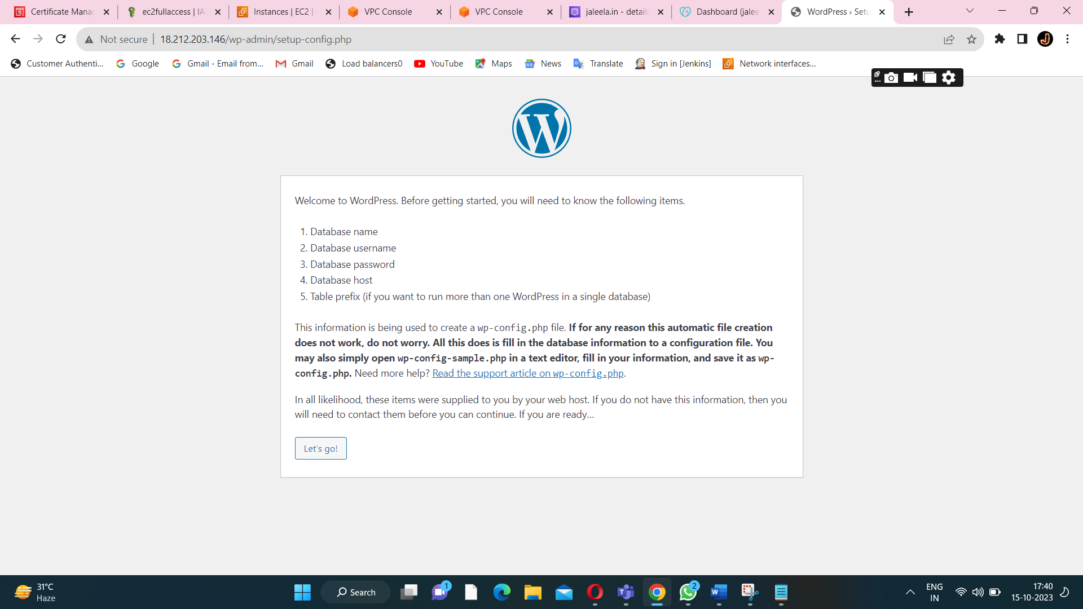

**After I copy the public ip address and hit in a chrome.we will get a wordpress page.(for both the instances).**

**STEP6:CREATE A LOAD BALANCER**

**Choose the application load balancer**

**To handle the traffic (to route the traffic to an instance).**

**After creating a loadbalancer we have a dns name.**

**To attach the loadbalancer to a instances.**

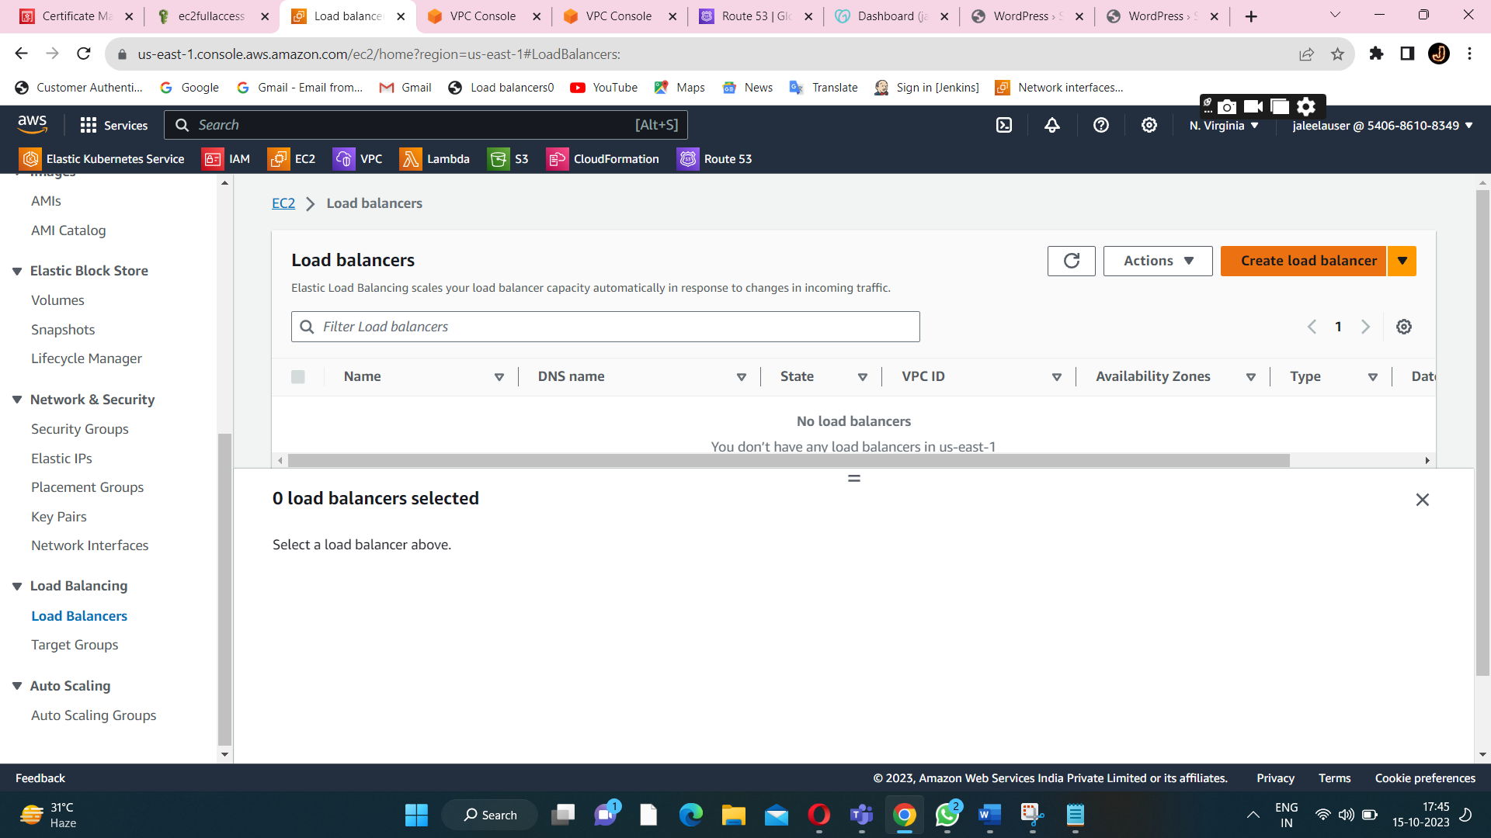

**Create a load balancer to handle the traffic.**

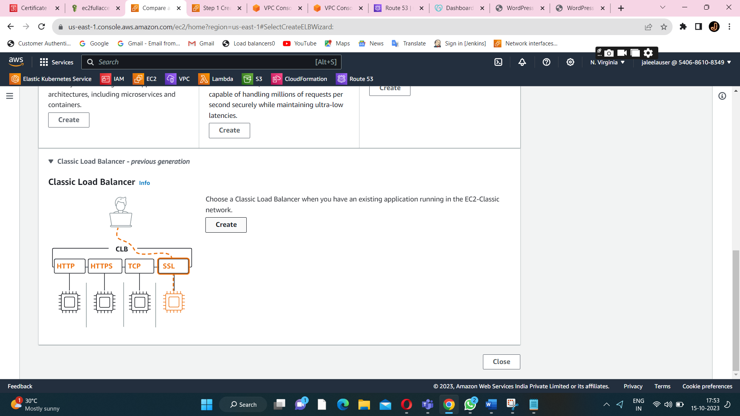

**Click on a classic load balancer.**

**Security group for a load balancer**

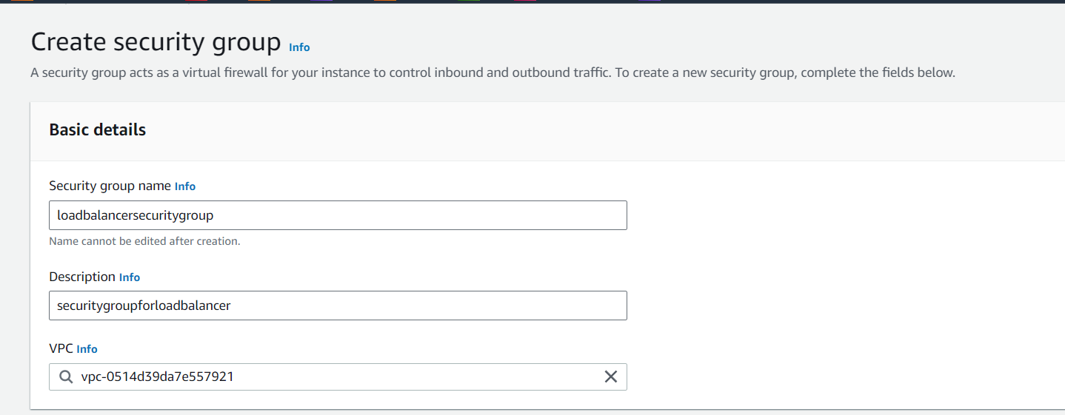

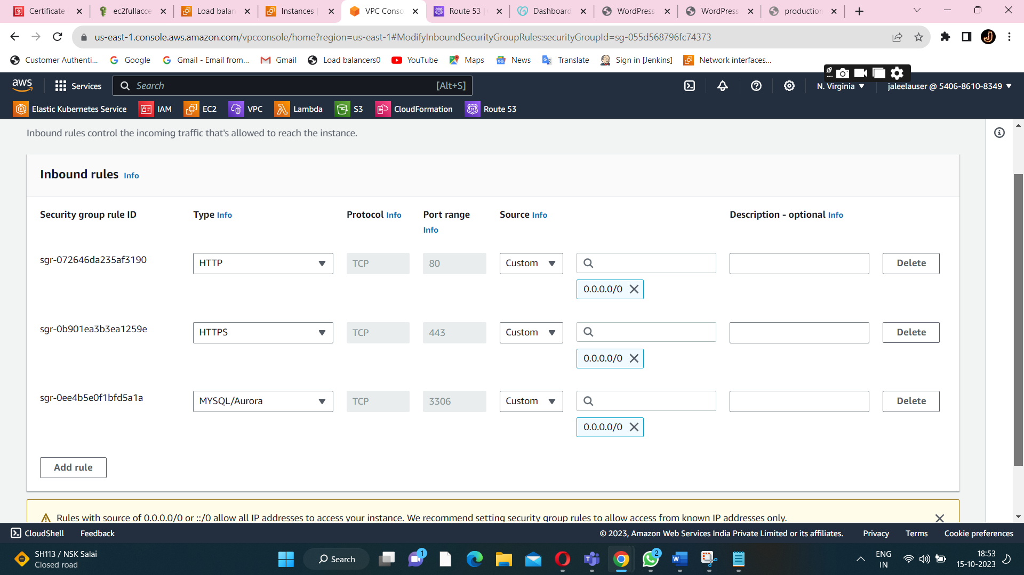

**Change the path healthy.html**

**Attach the necessary inbound-rule for a loadbalancer security group.**

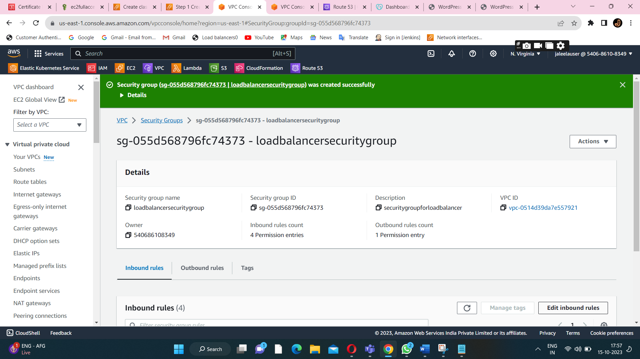

**Security group is created successfully.**

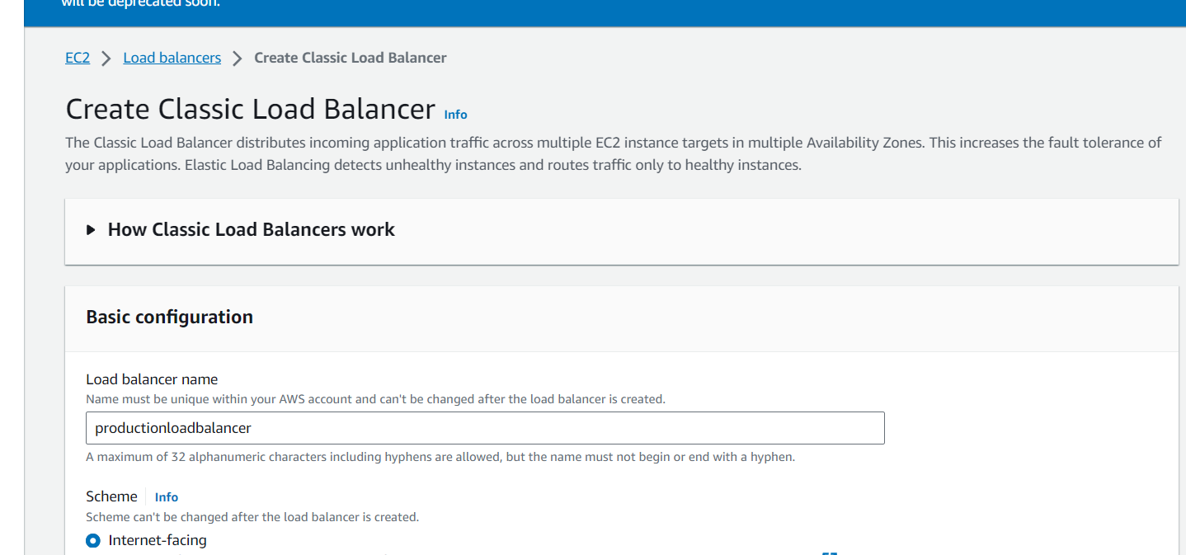

**Create a load balancer.**

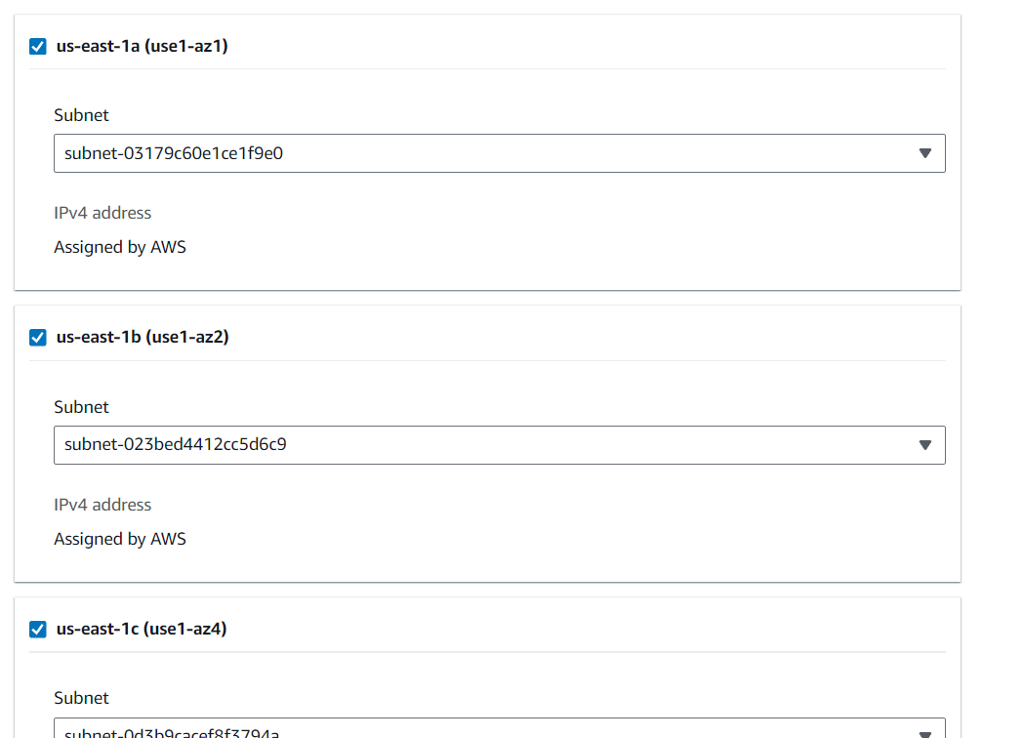

**Attached the subnet to a load balancer.**

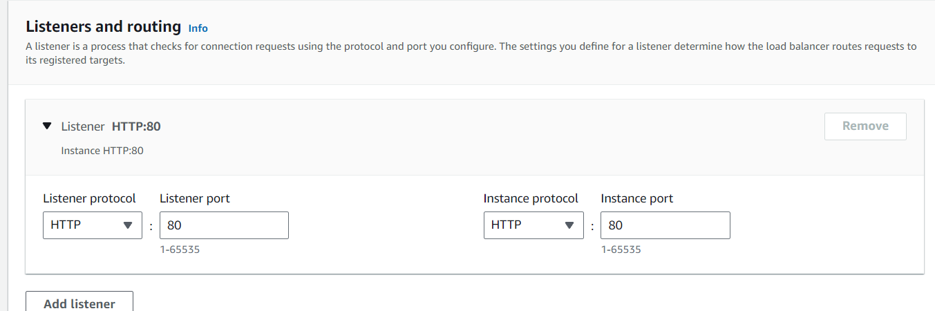

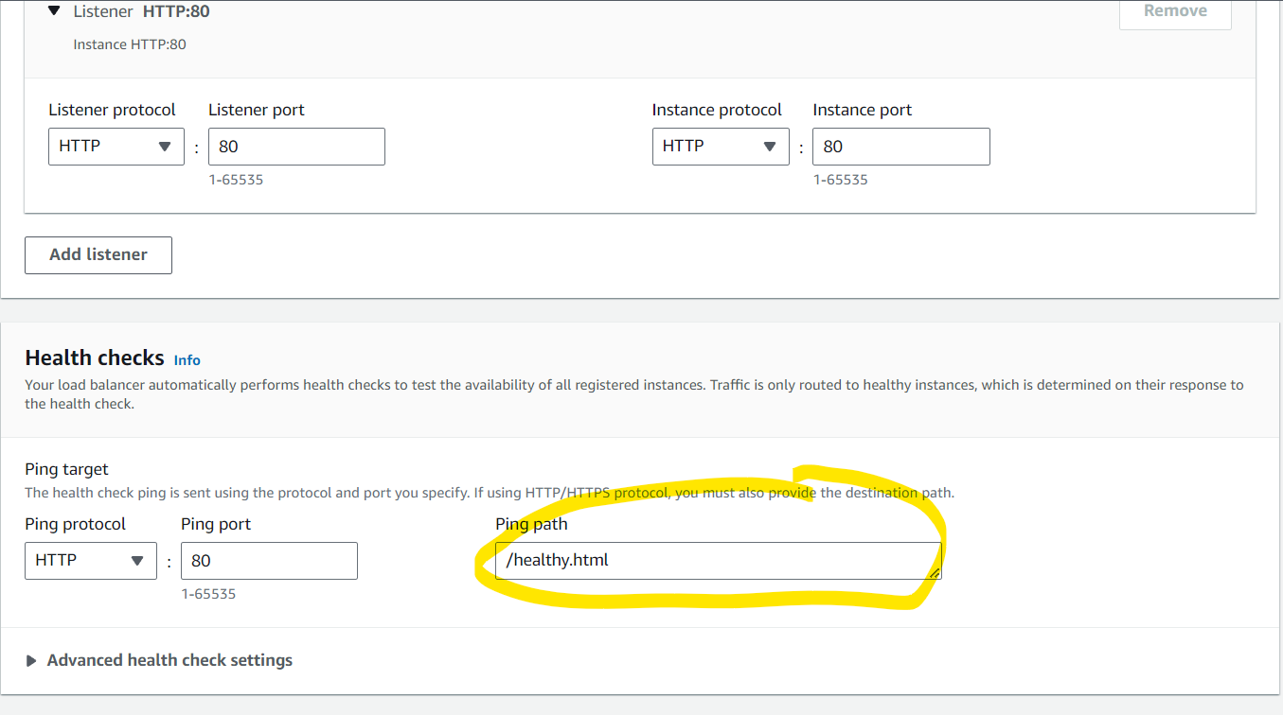

**Change the path for healthy.html**

**Listener is used to route the traffic to a necessary instance.**

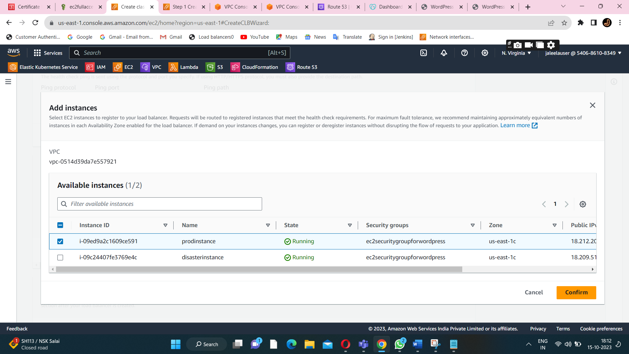

**Attach the instance to a loadbalancer.**

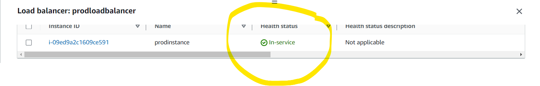

**Instance is should be in-service(instance is available)**

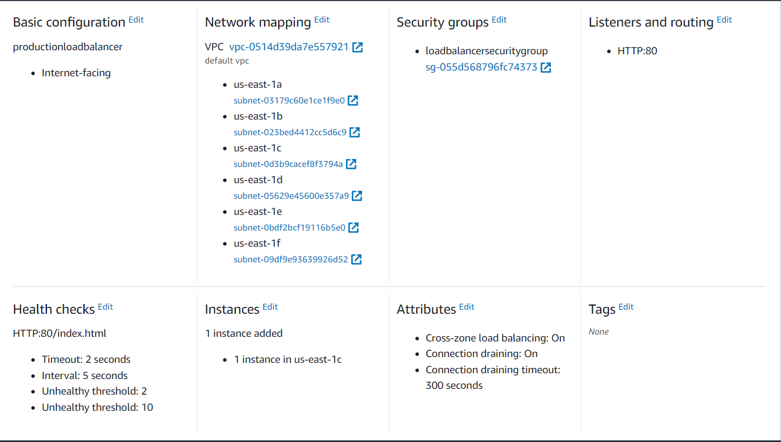

**Click on create load balancer.**

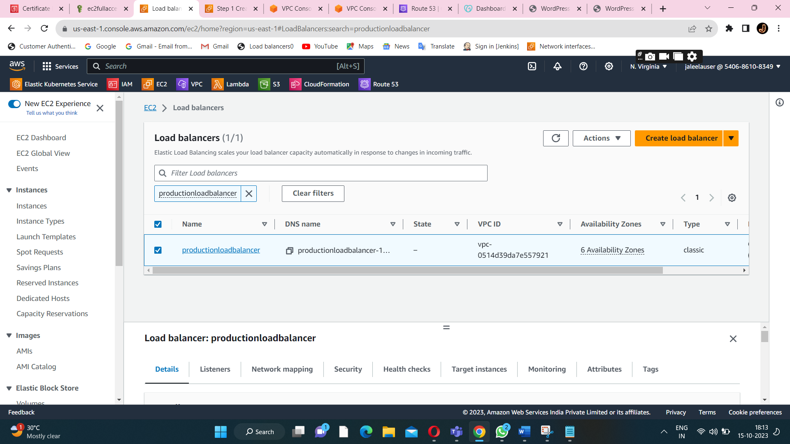

**Load balancer is created successfully.**

**Keep all the configuration has it is and create a load balancer.**

**Attach the necessary subnet for high availability.**

**Then choose the endpoint of DNS (Domain name of a load balancer).**

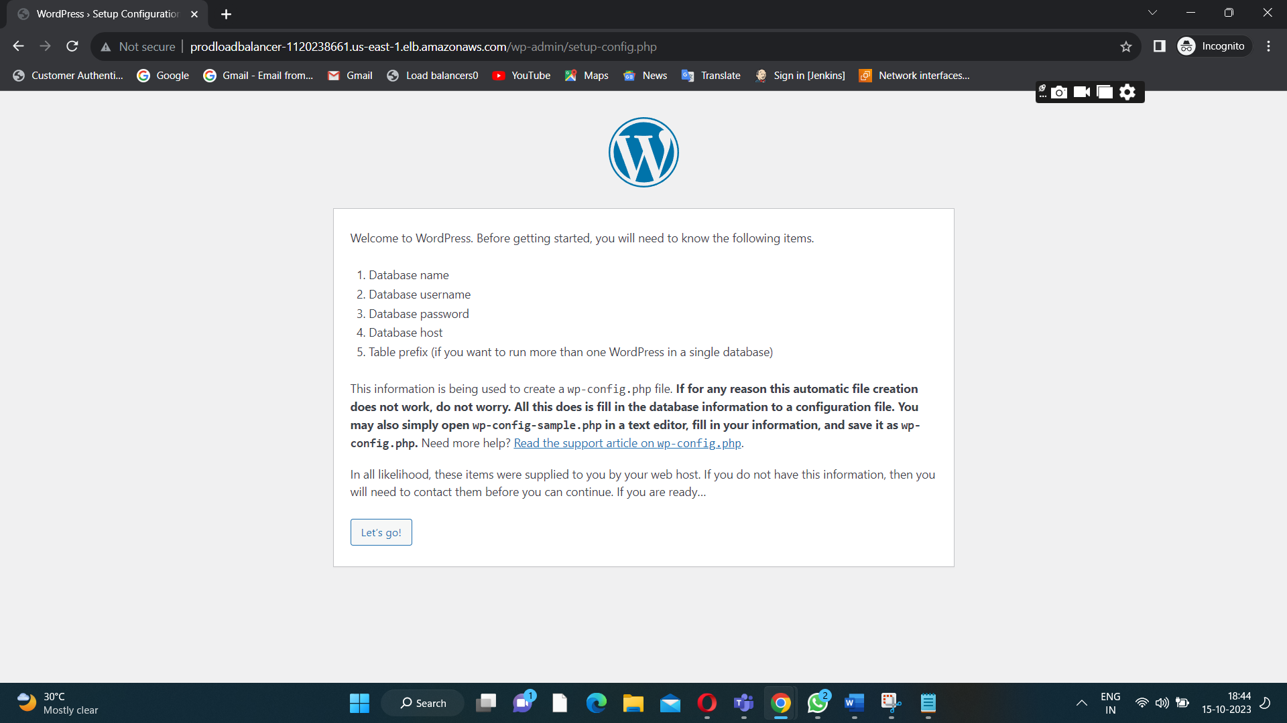

**Ping on the incognito-window.Got a same wordpress output in a ec2-instance.**

**DISASTER LOADBALANCER**

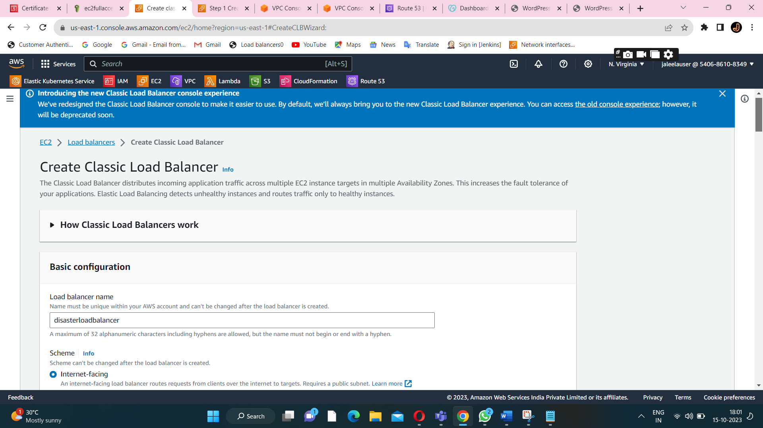

**Add the same load balancer security group to a disaster instance**

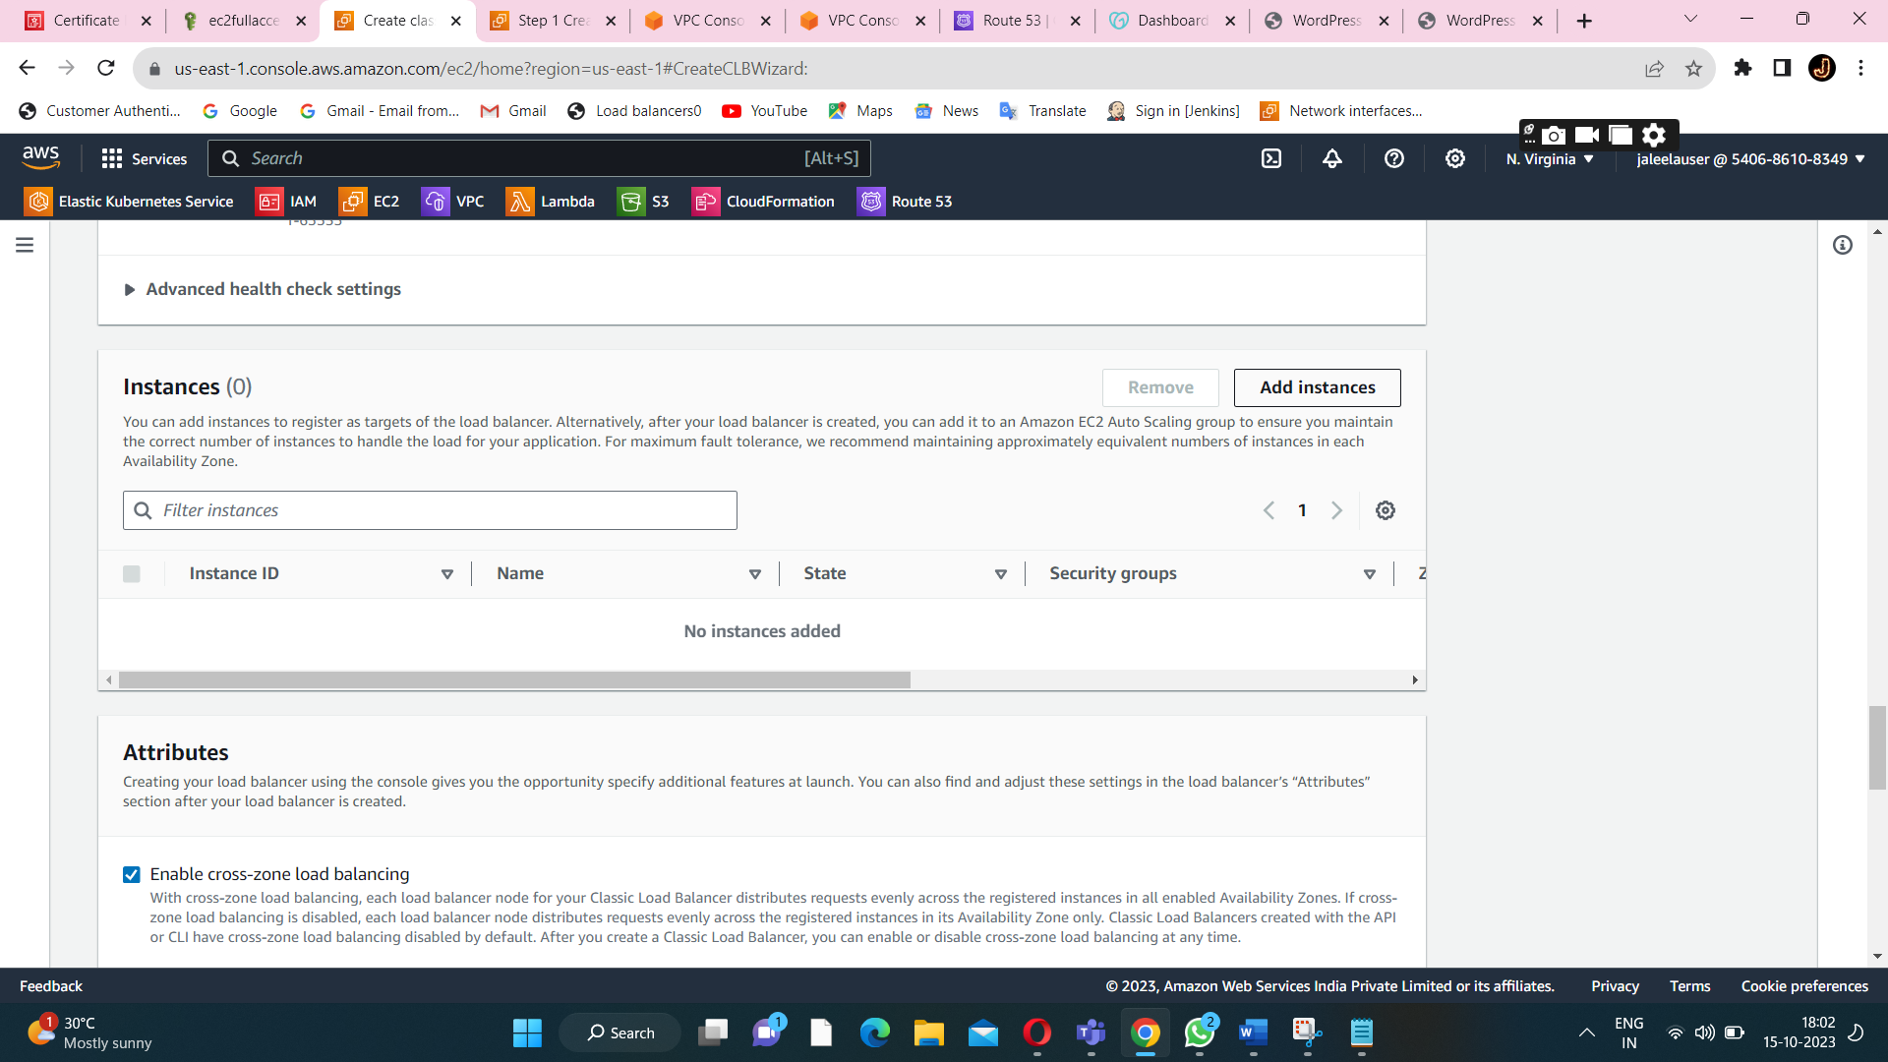

**Click on add instance to add the required instance.**

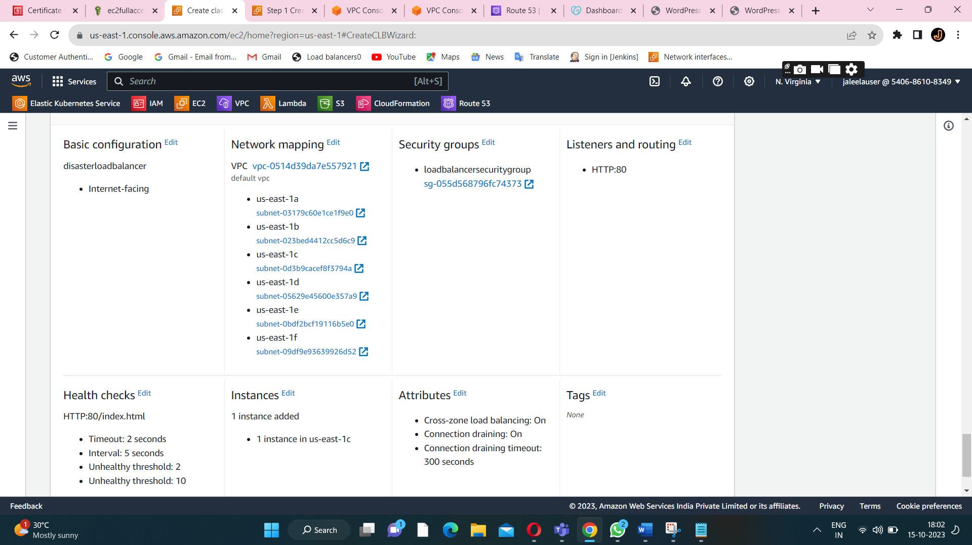

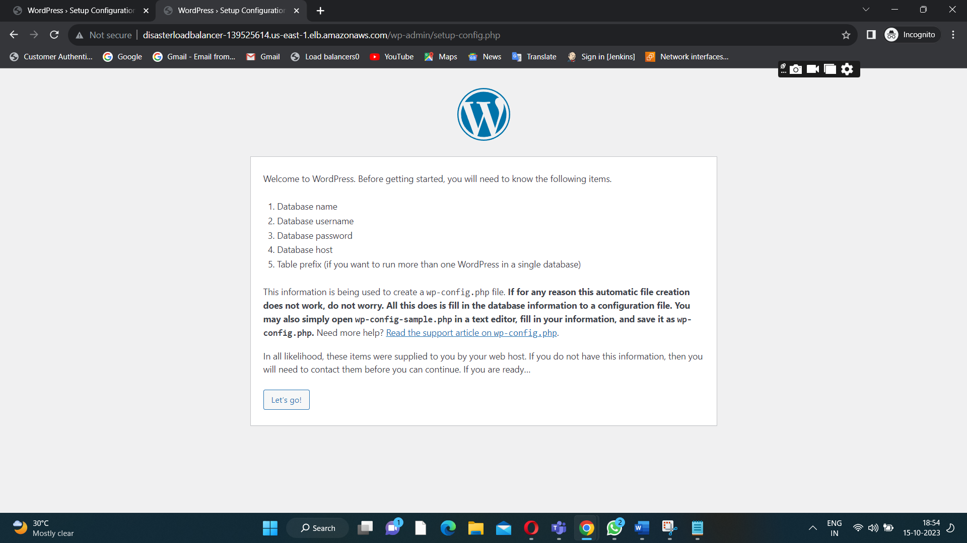

**Now I ping the DNS of a disasterloadbalancer got the same wordpress as a output.**

**Both the production and disaster recovery load balancer is created successfully.**

**STEP7:CONNECT AN EC2 INSTANCE TO A DB INSTANCE**

**Conncet the production instance.**

**To connect the RDS (db instance) install the MYSQL on a production instance.**

**Commands:sudo su,yum install mysql**

**Endpoint of db instance is used to connect EC2 instance.**

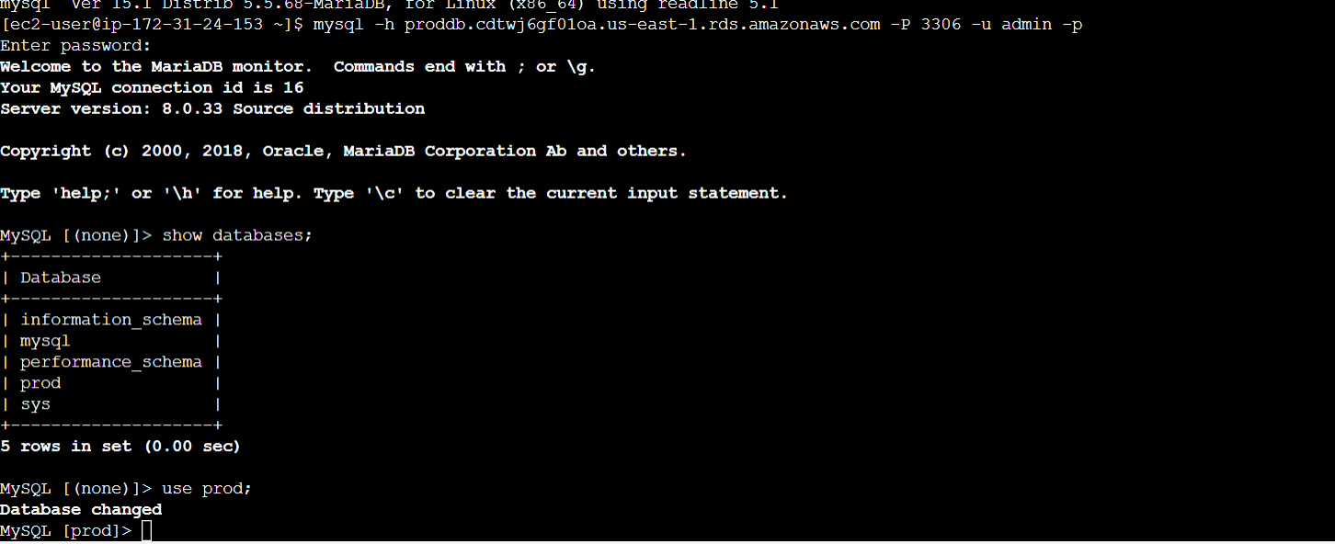

**mysql -h proddb.cdtwj6gf01oa.us-east-1.rds.amazonaws.com -P 3306 -u admin -p(for connecting RDS instance and EC2-INSTANCE).**

**this command is used to connect ec2 instance to db instance.**

**Same db creation for disaster DB creation.**

**Using the security group,assign the name to a disaster db.**

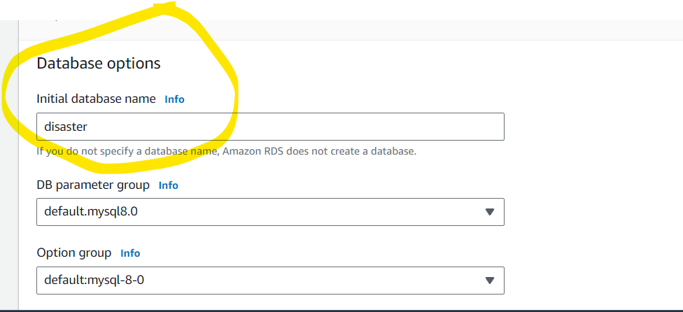

**Initial database name:disaster is need to provide because of then only database is created in MYSQL db instance.**

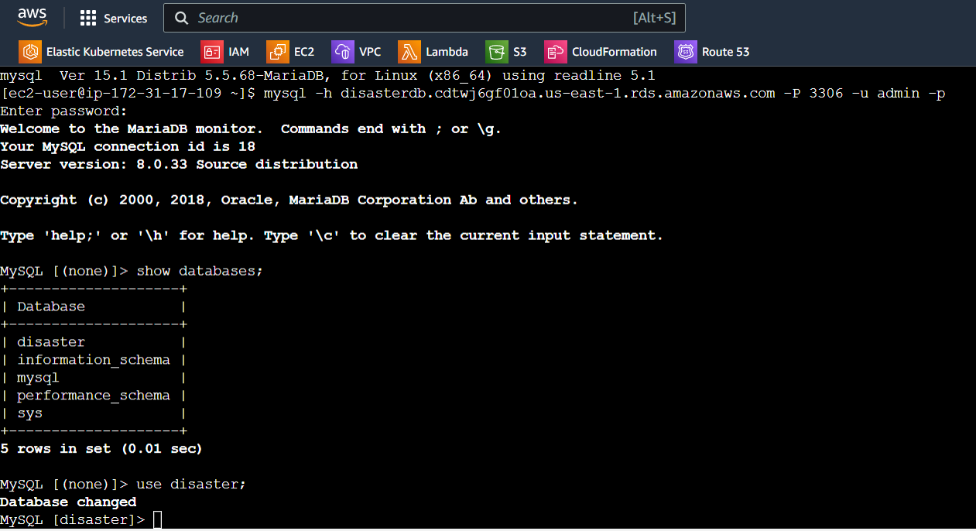

**Same configuration,endpoint and security group is applicable for disaster db(then we connect ec2 to RDS (db instance)).**

**SECURITY GROUP FOR RDS(MYSQLDB)**

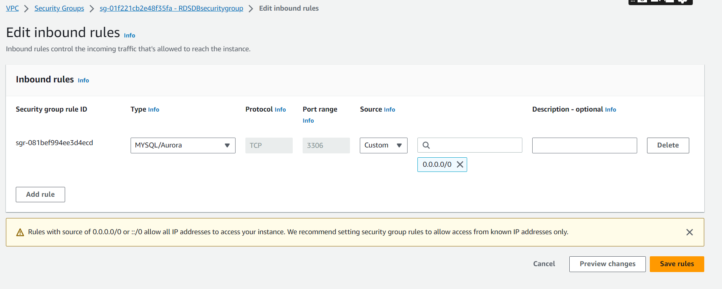

**Security group for RDS INSTANCE should have a MYSQL/Aurora: port-number is 3306.**

**STEP8:Connect the wordpress using db credentials.**

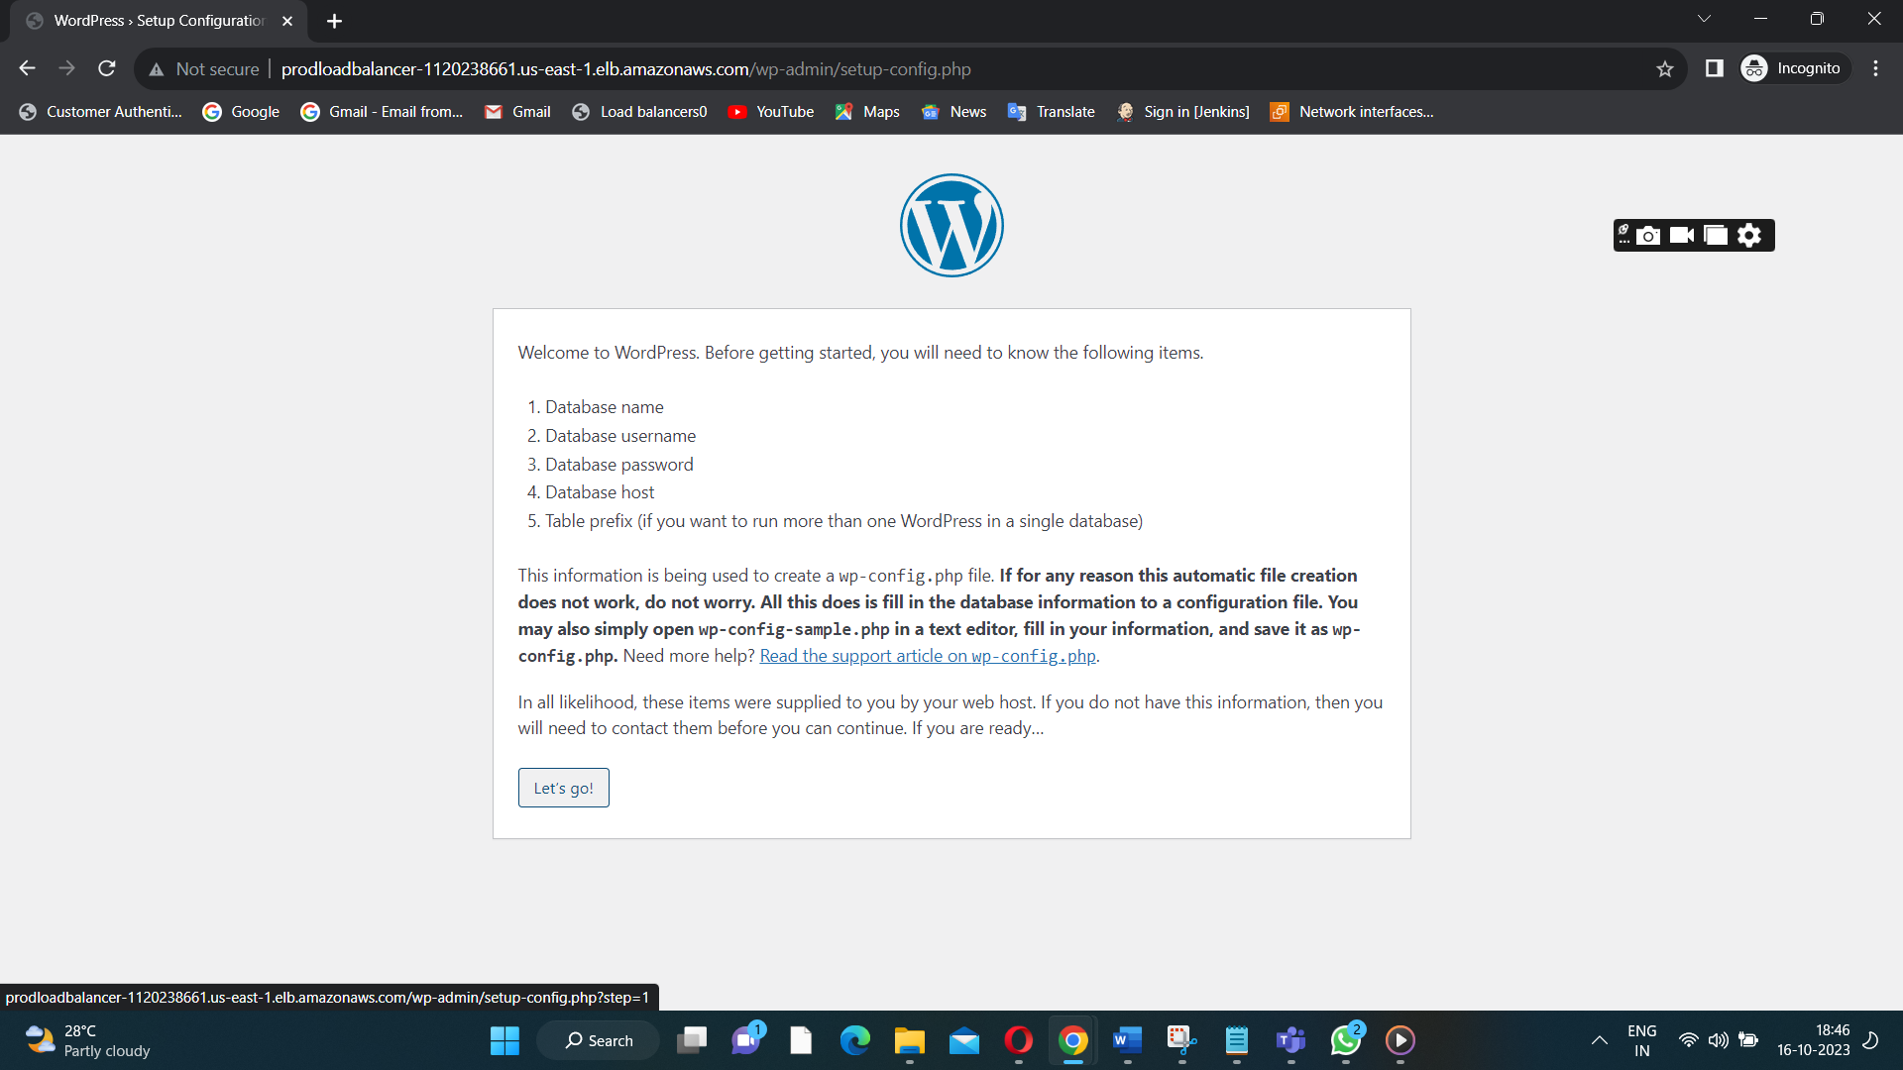

**Click on let’s go.**

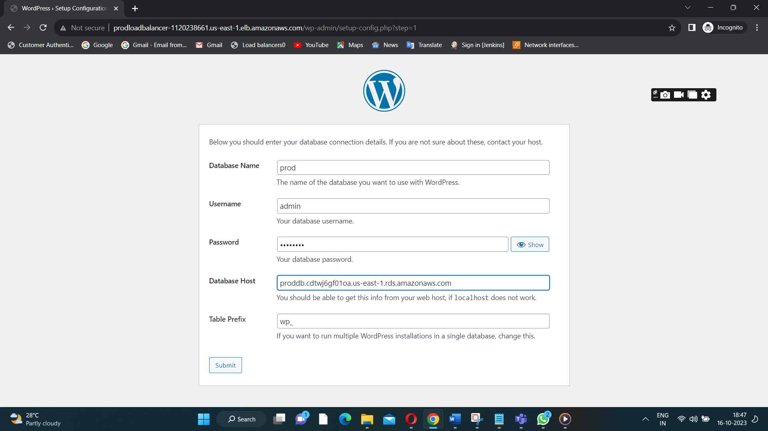

**Provide all the proddb credentials.**

**Click on submit.**

**We got the configuration file.**

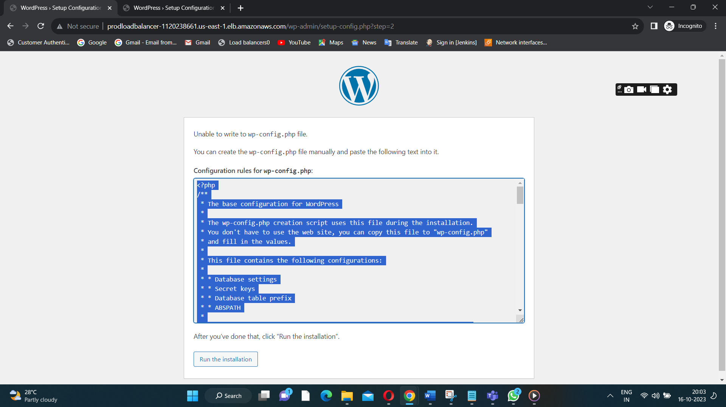

**Manually attach the config file in a wordpress.**



**Inside the cd /var/www/html path all the files are there.**

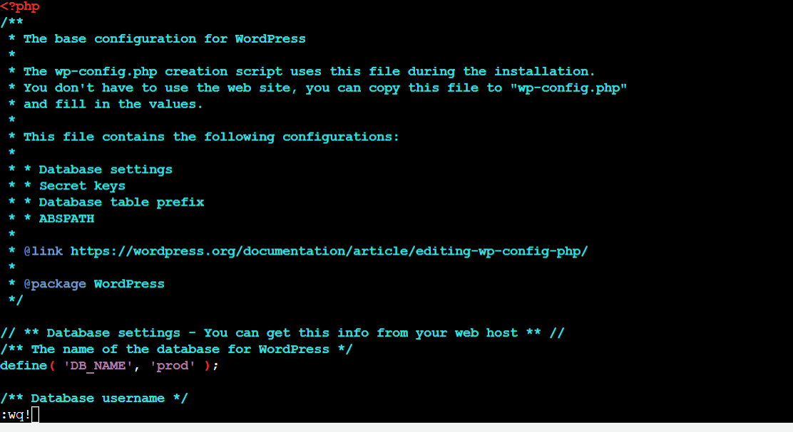

**After entering the file inside the vi wp-config.php we can run the installation path.**

**Config the file for a software listener.**

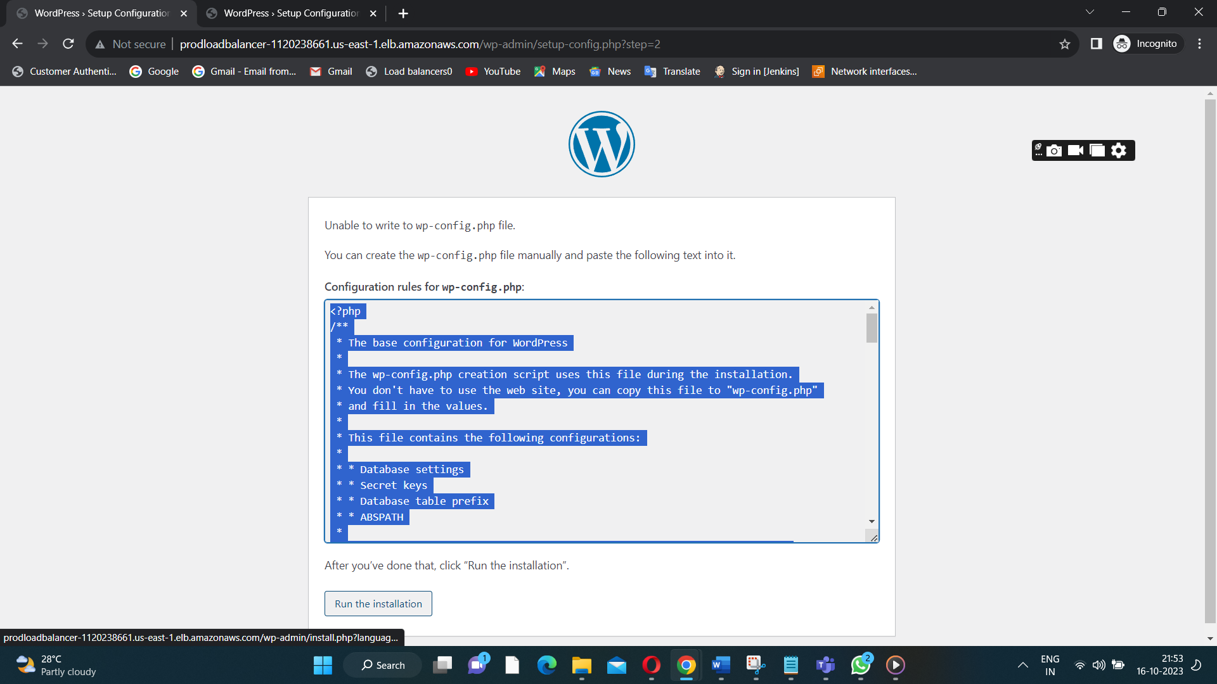

**Click run the installation.**

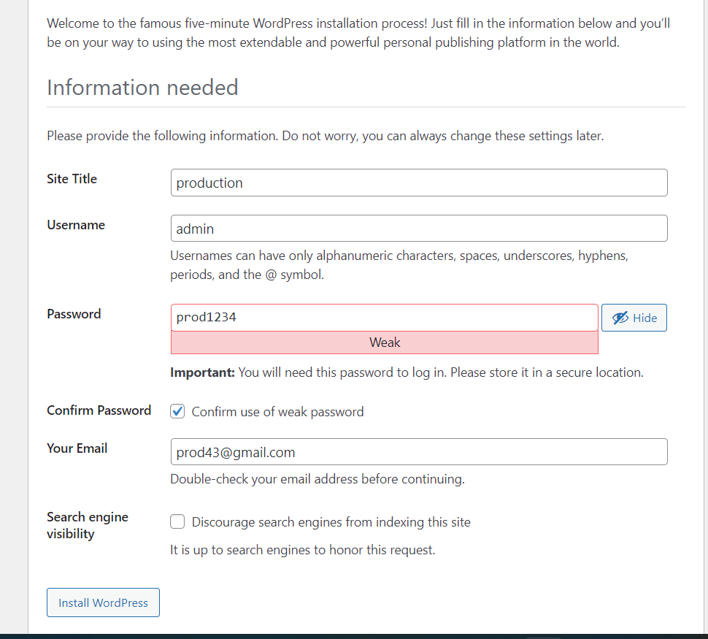

**After providing our own credentials we should install wordpress.**

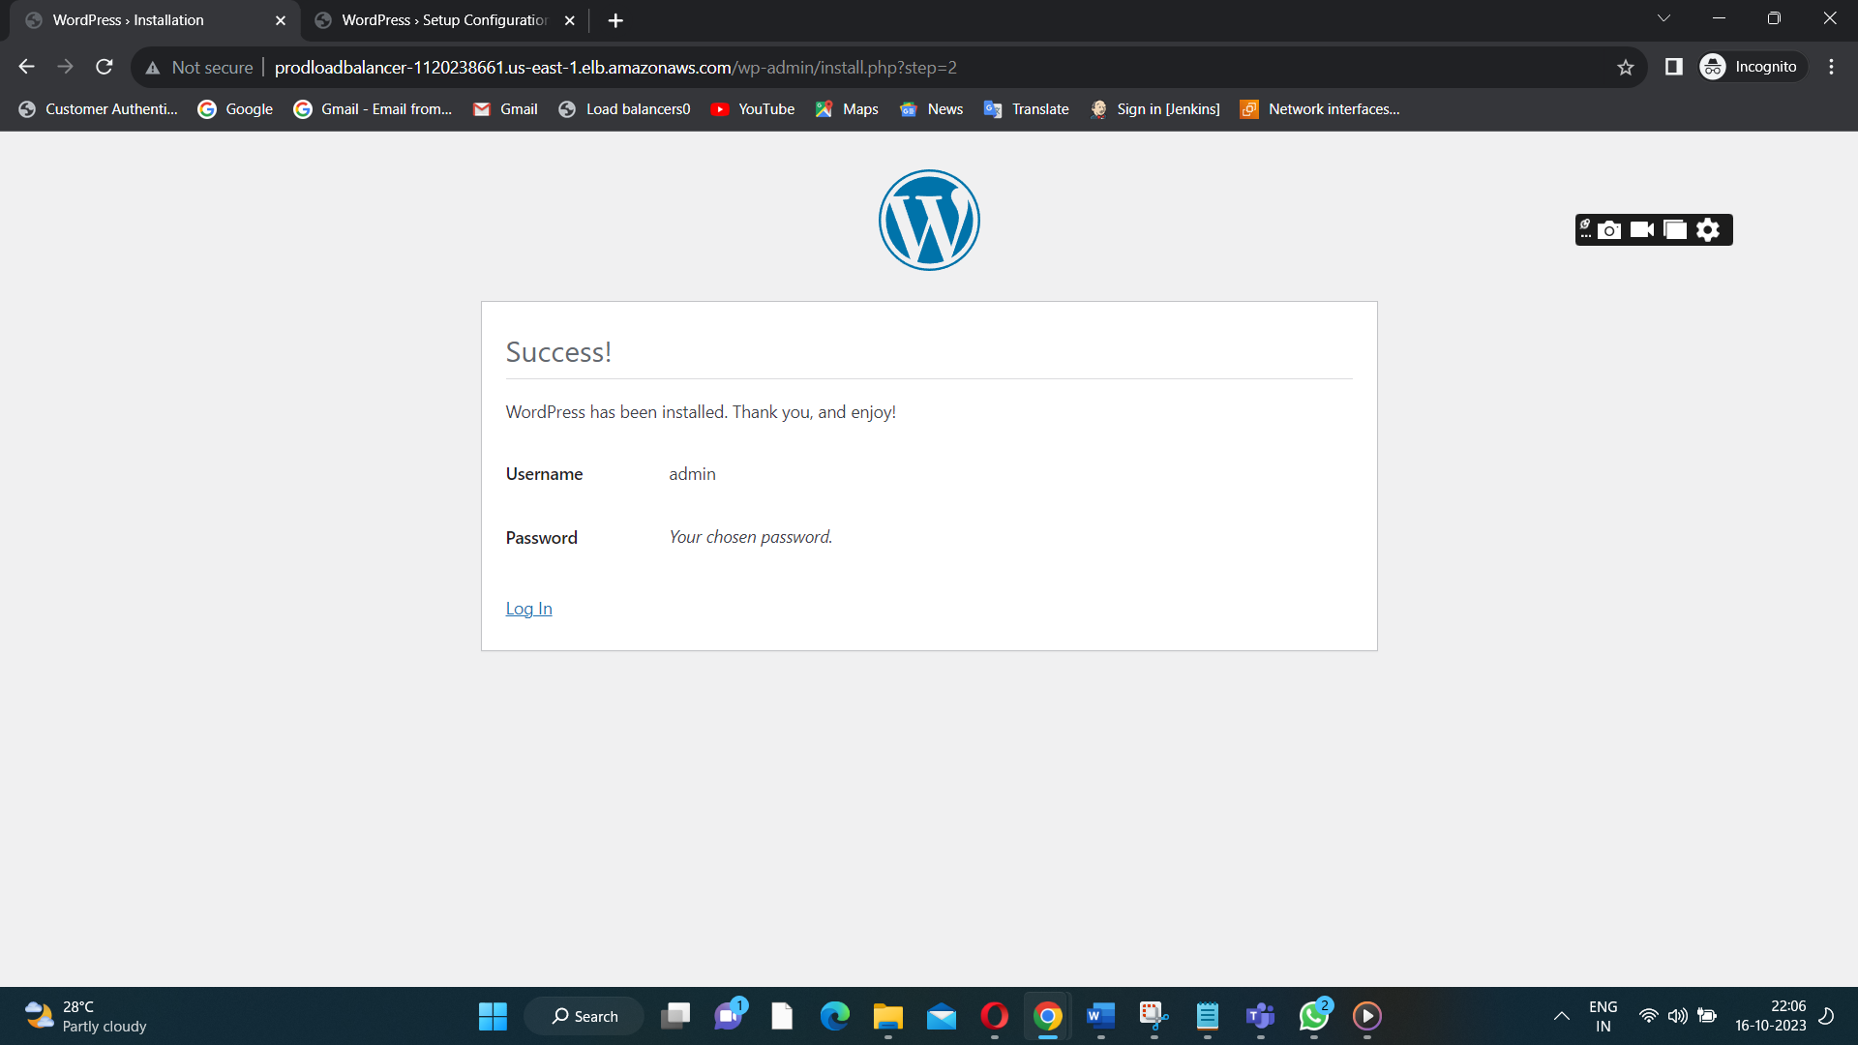

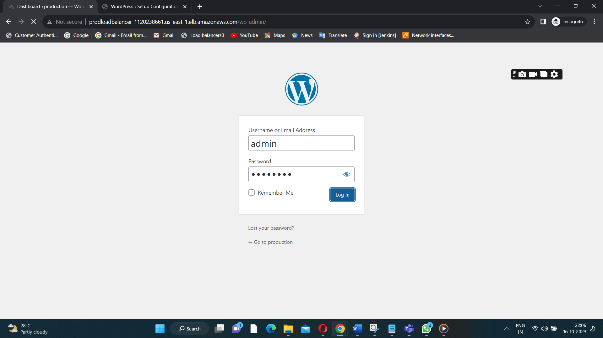

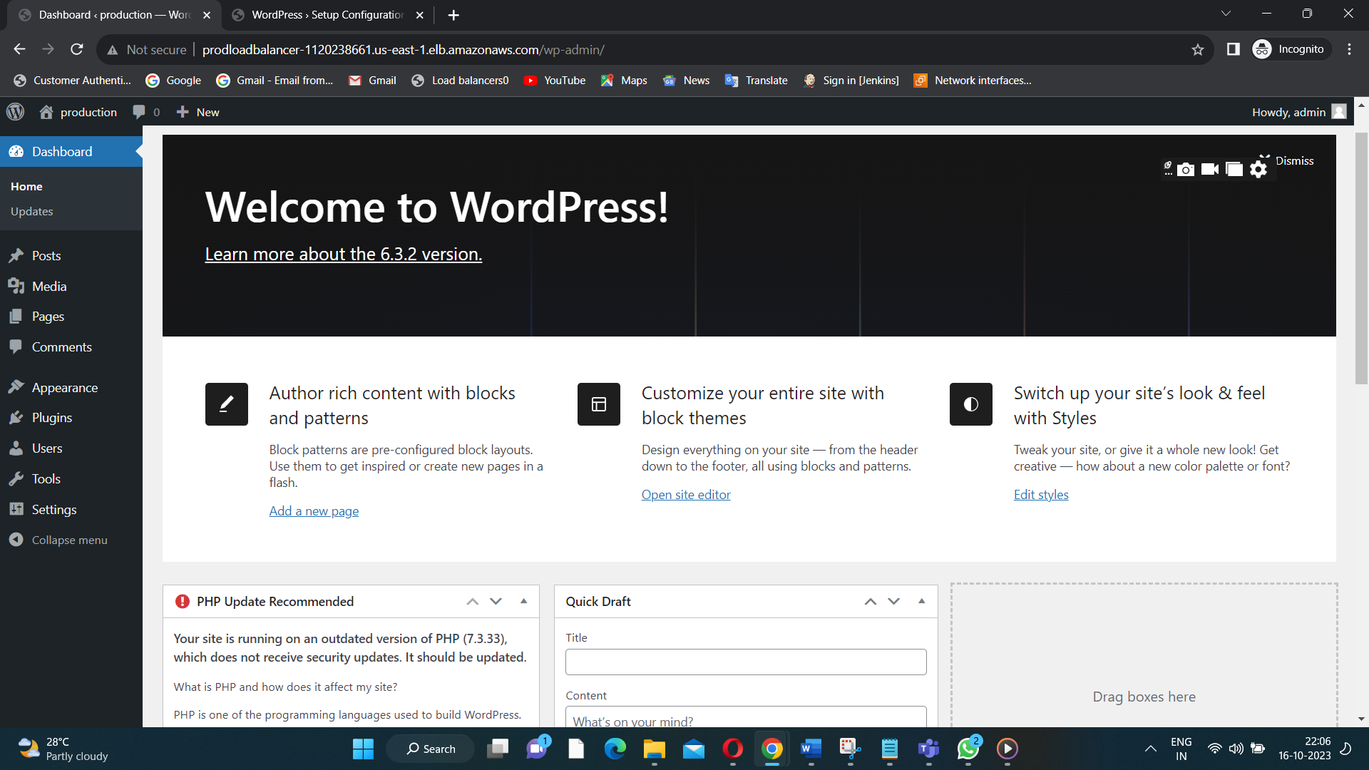

**Wordpress page will get displayed.**

**Same process we need to done for another (disaster machine).**

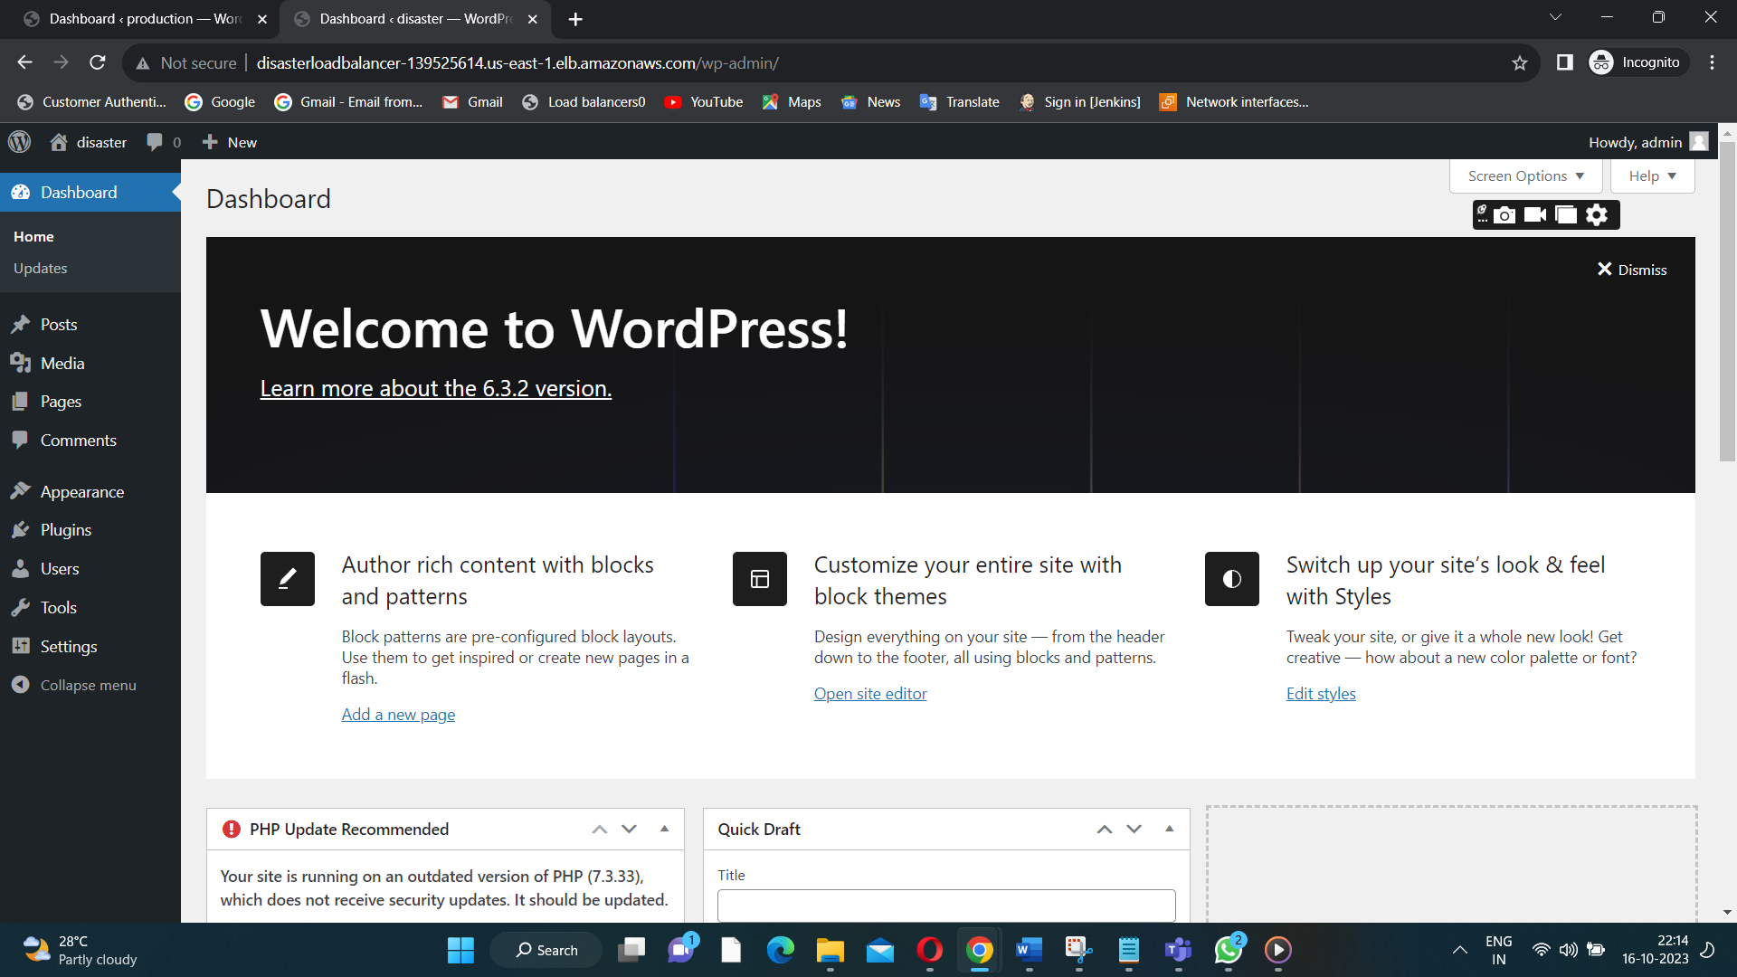

**Wordpress page for disasterinstance(need to wp-config.php) in a cd /var/www/html file path.**

**I want a different content in my production and disaster wordpress.**

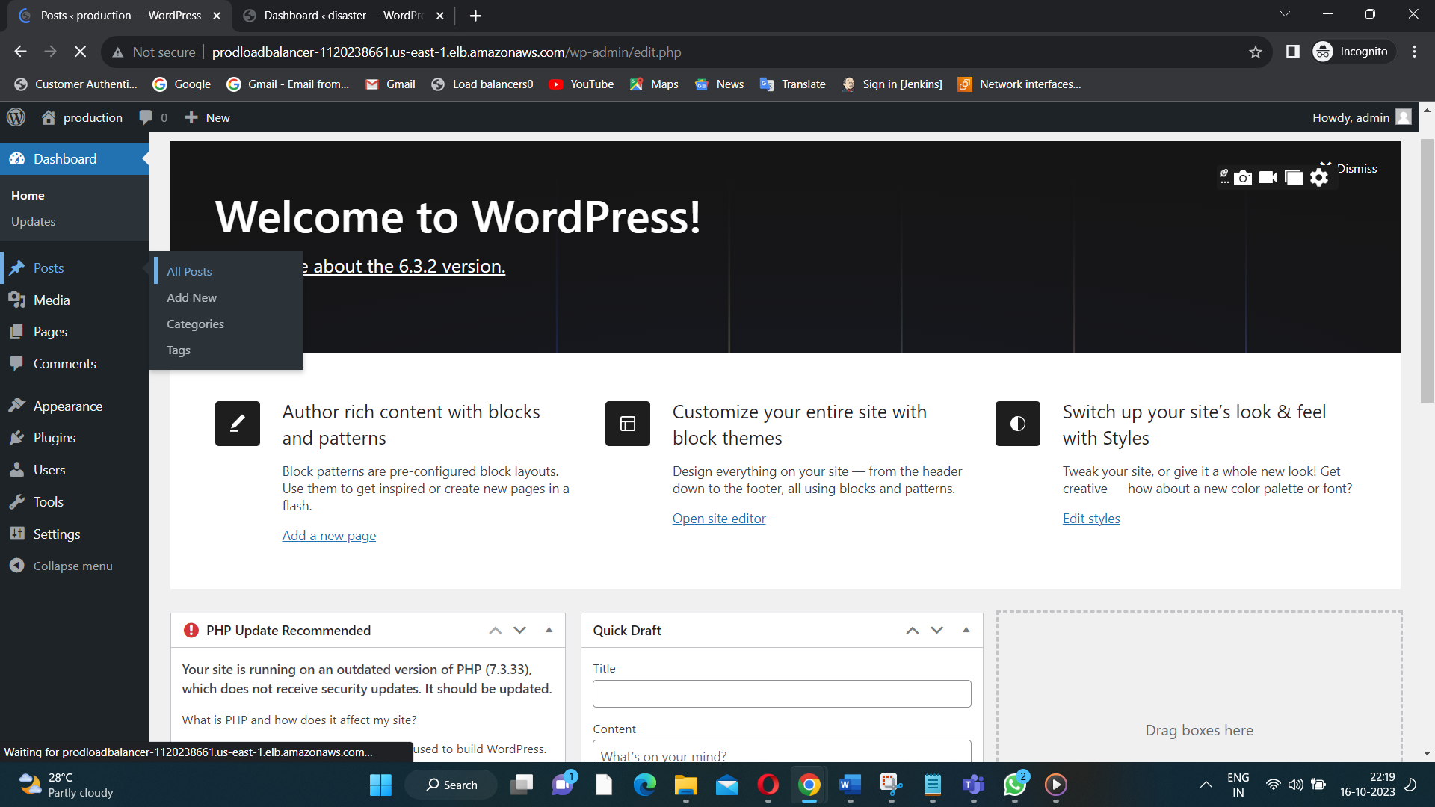

**Click on post and all posts.**

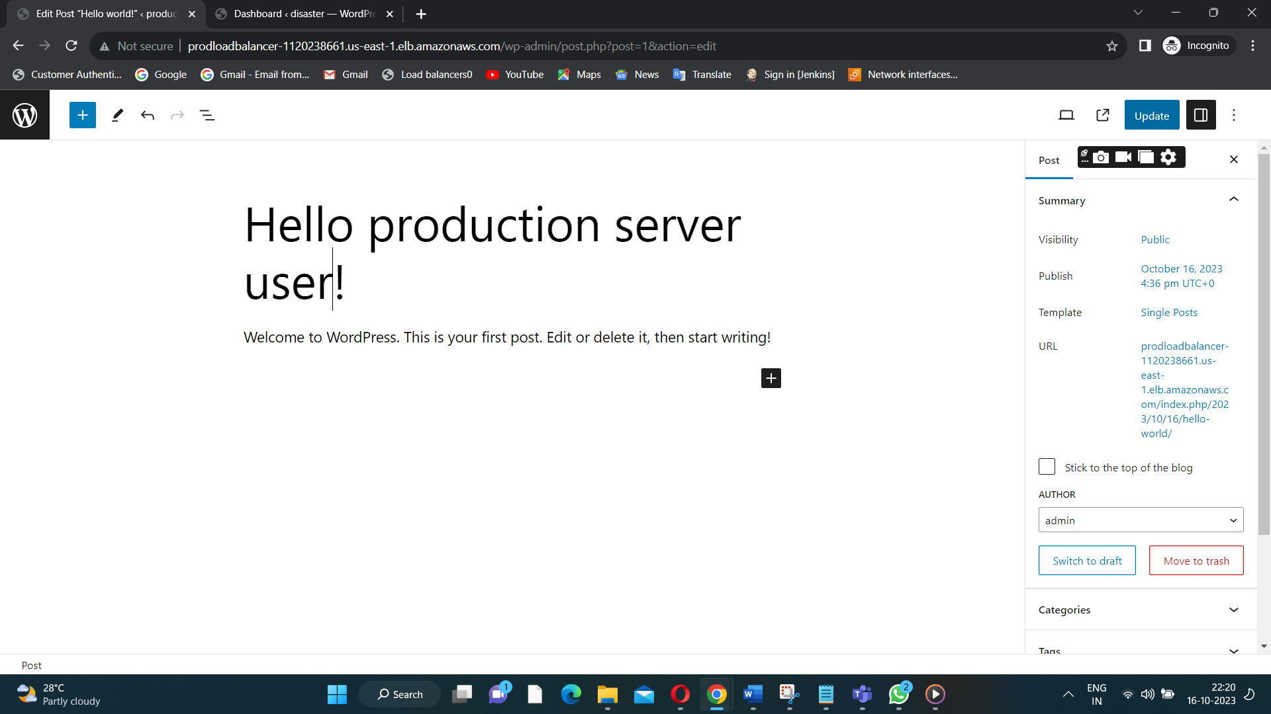

**Give the message and click on updating.**

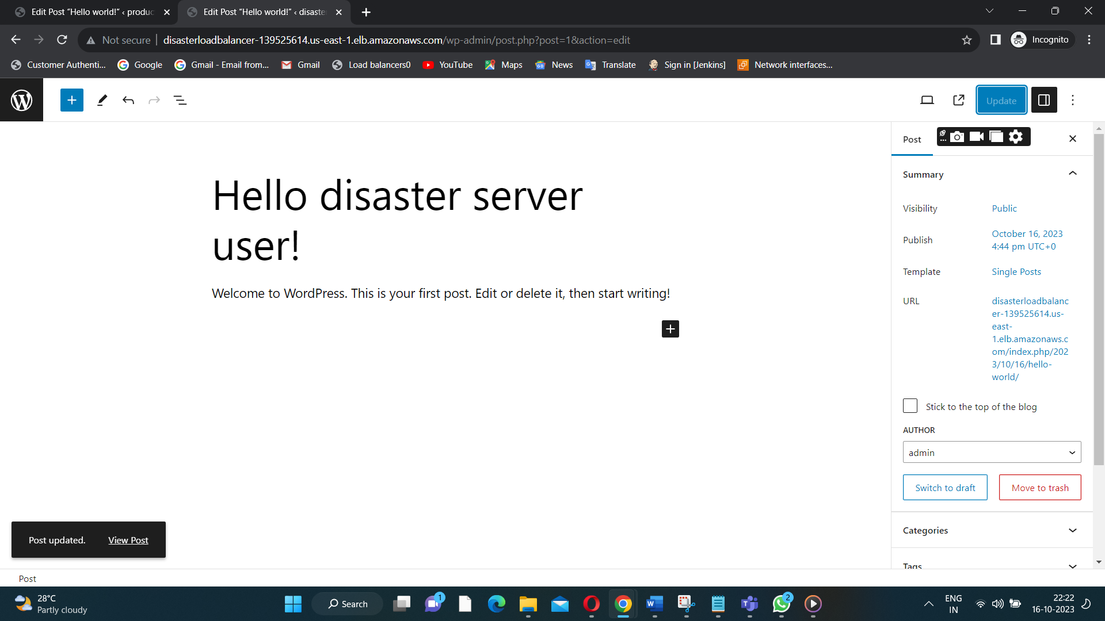

**Disaster server wordpress update(post updates).**

**Just editing the content on both the servers.**

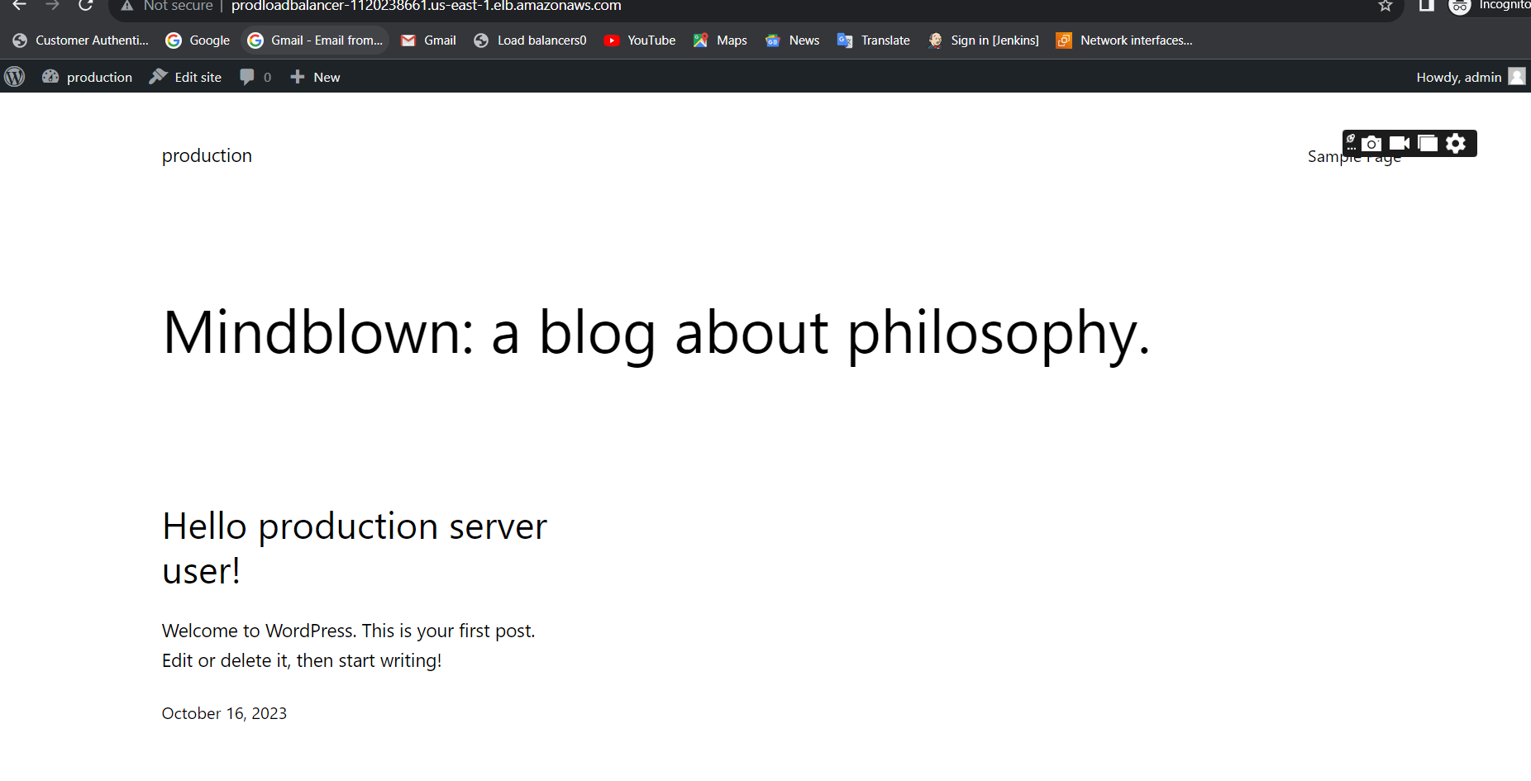

**Now I ping with productionloadbalancer(I got the output)like this.**

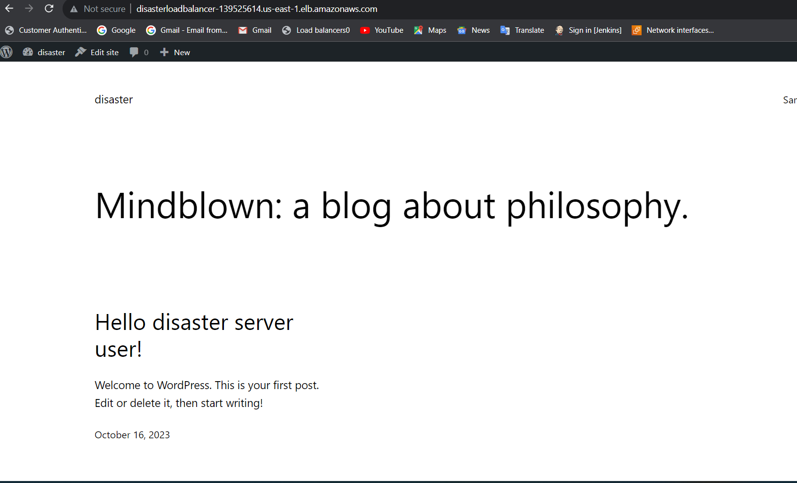

**Now I pin with a disaster load balancer(I got the output of updated content).**

**STEP9:CONNECT A ROUTE53.**

**Create a record and route a traffic to a destinated load balancer.**

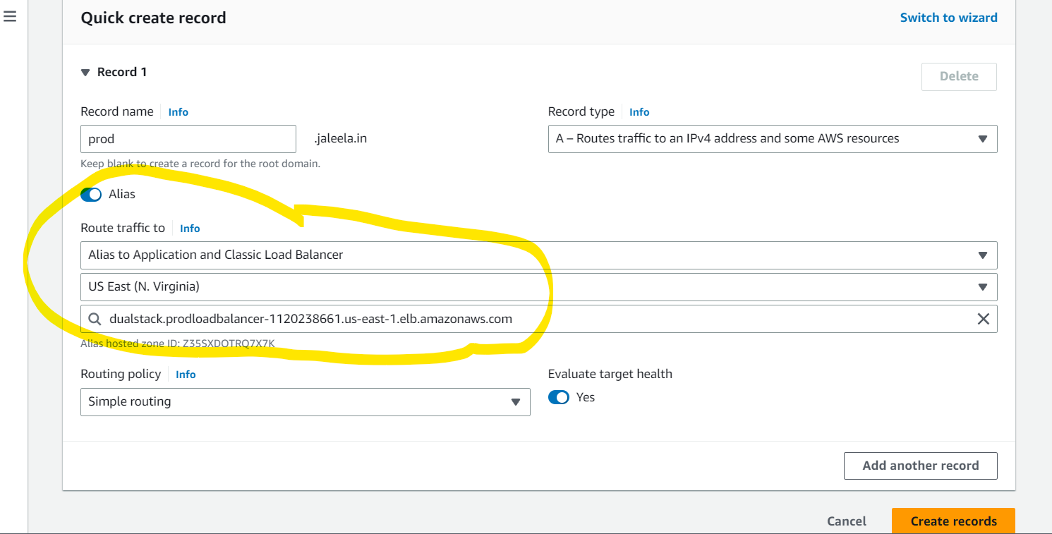

**Alias to be choosen to route the traffic to a destinated load balancer.(for production server we choose production load balancer).**

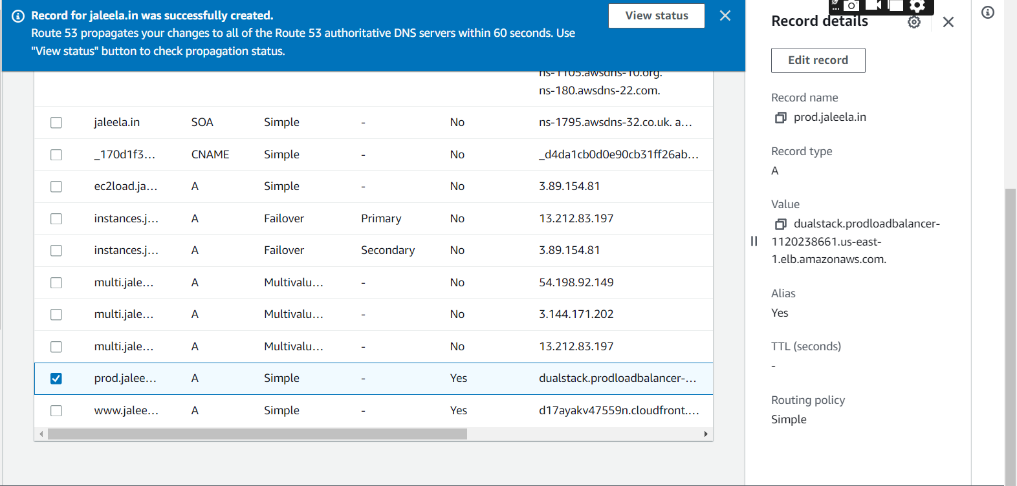

**Record for production(prod.jaleela.in)-domain is created successfully.**

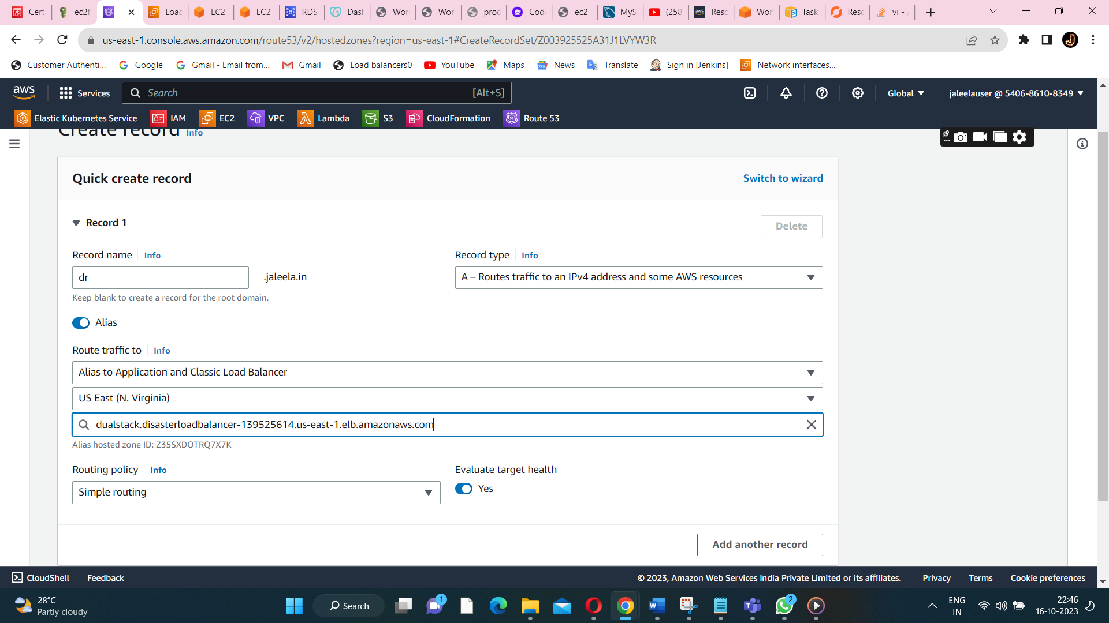

**For the disaster too we can create a record.**

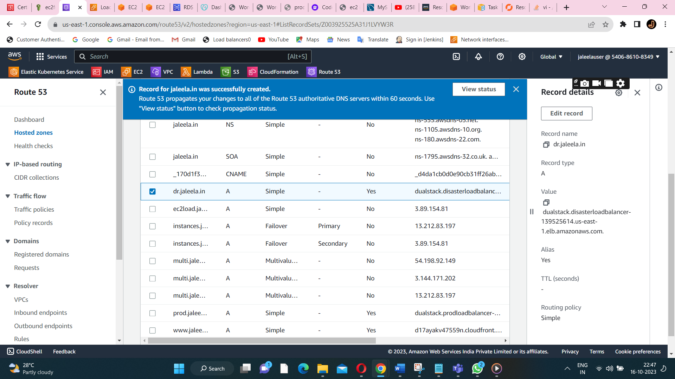

**Disaster too record is created successfully.**

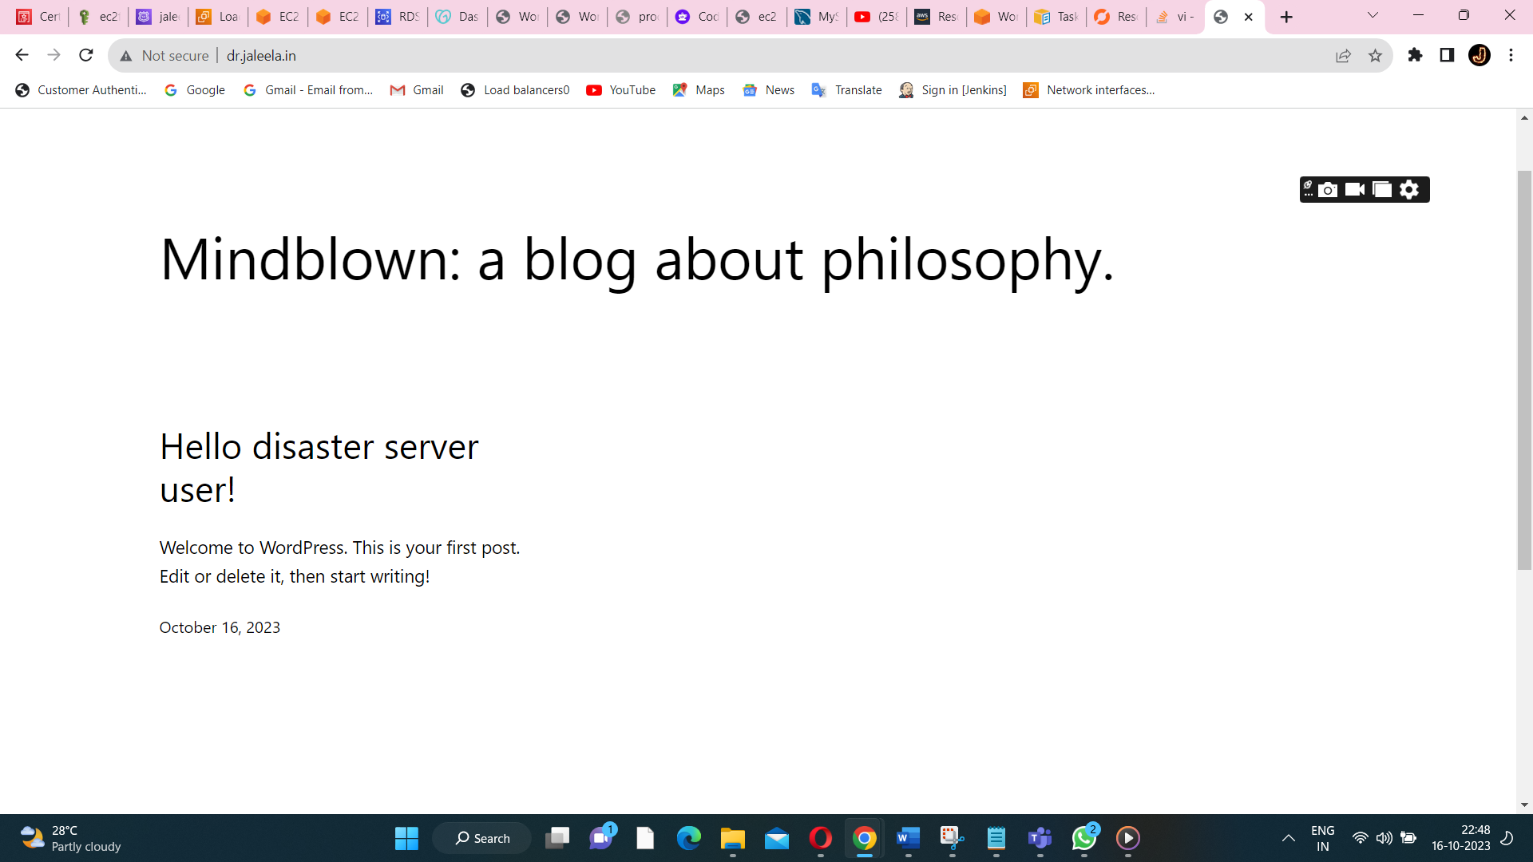

**Now I ping the dr.jaleela.in,I got the output of a wordpress(for disaster server).**

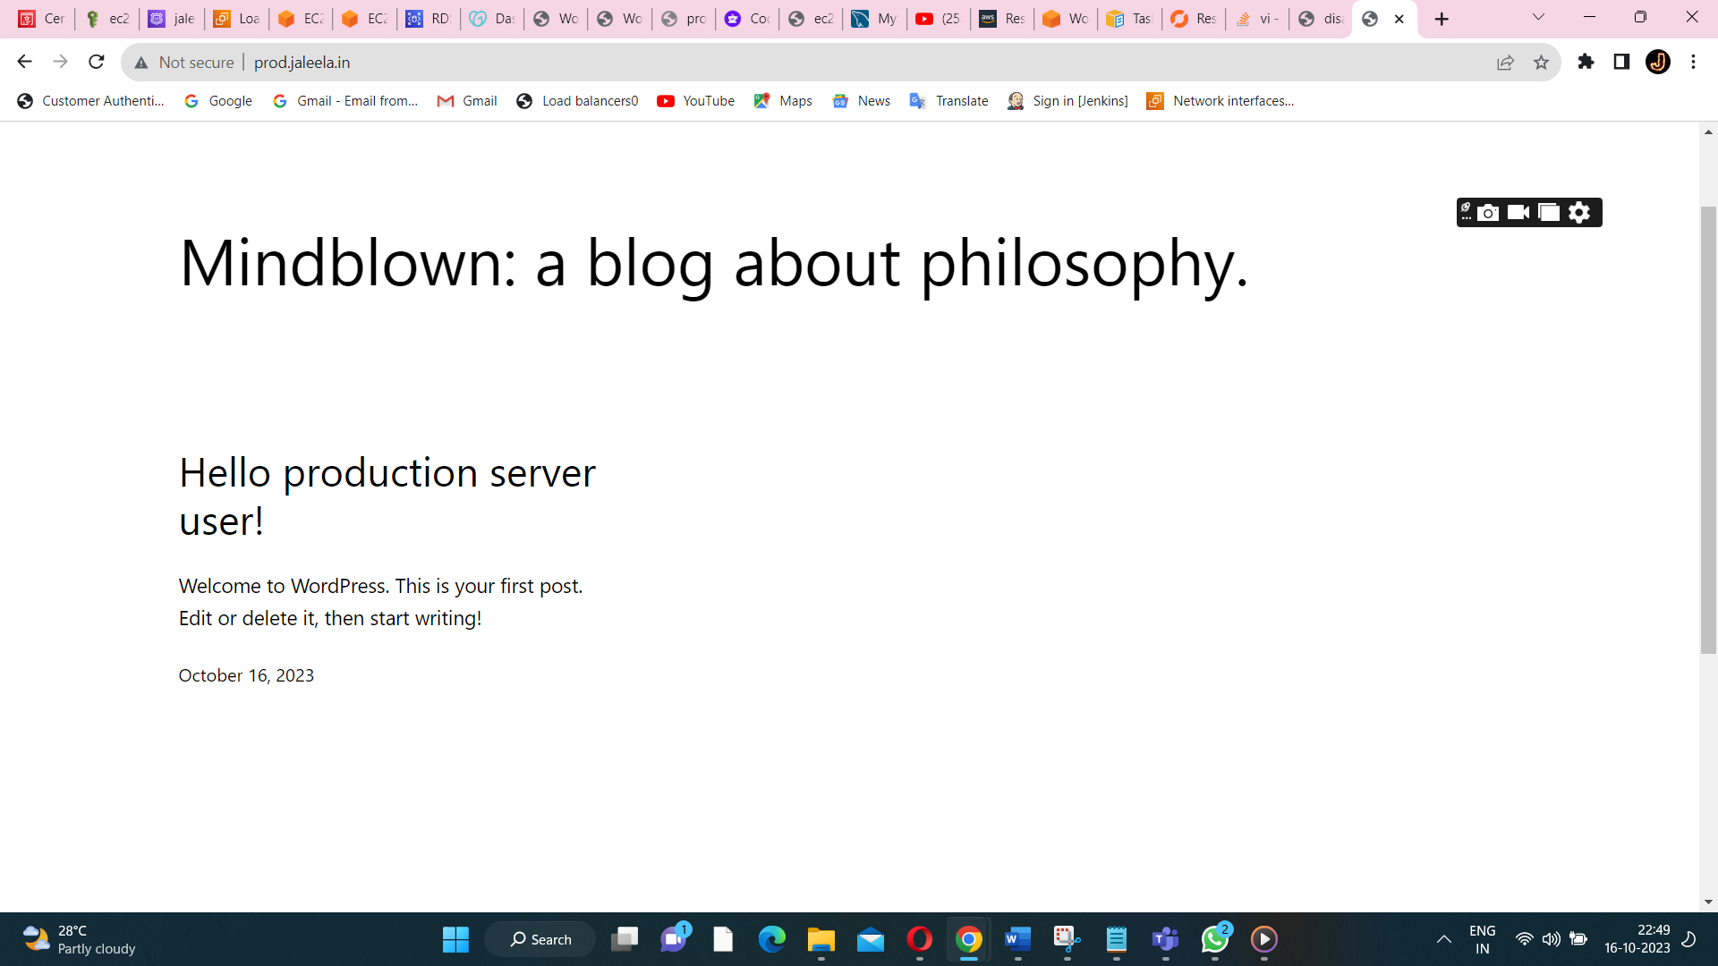

**For prod.jaleela.in(we got the output of a wordpress of productions server).**

**But both the domain name is not secured.**

**STEP10:DISASTER RECOVERY**

**Two create a two s3 bucket for storing code level content and a another bucket is for storing a media level content.**

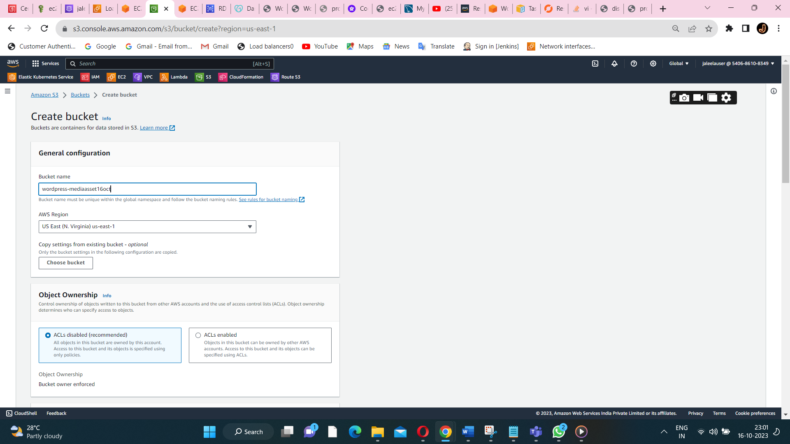

**One of the bucket name is wordpress-mediaasset16oct(one bucket is used for storing media files).**

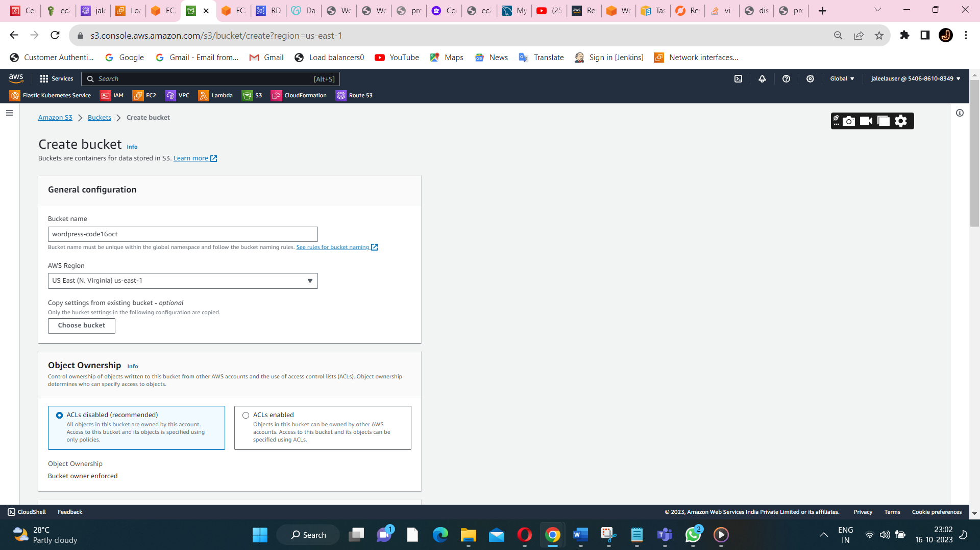

**Create a another bucket for storing a code.**



**Both the bucket is created successfully.**

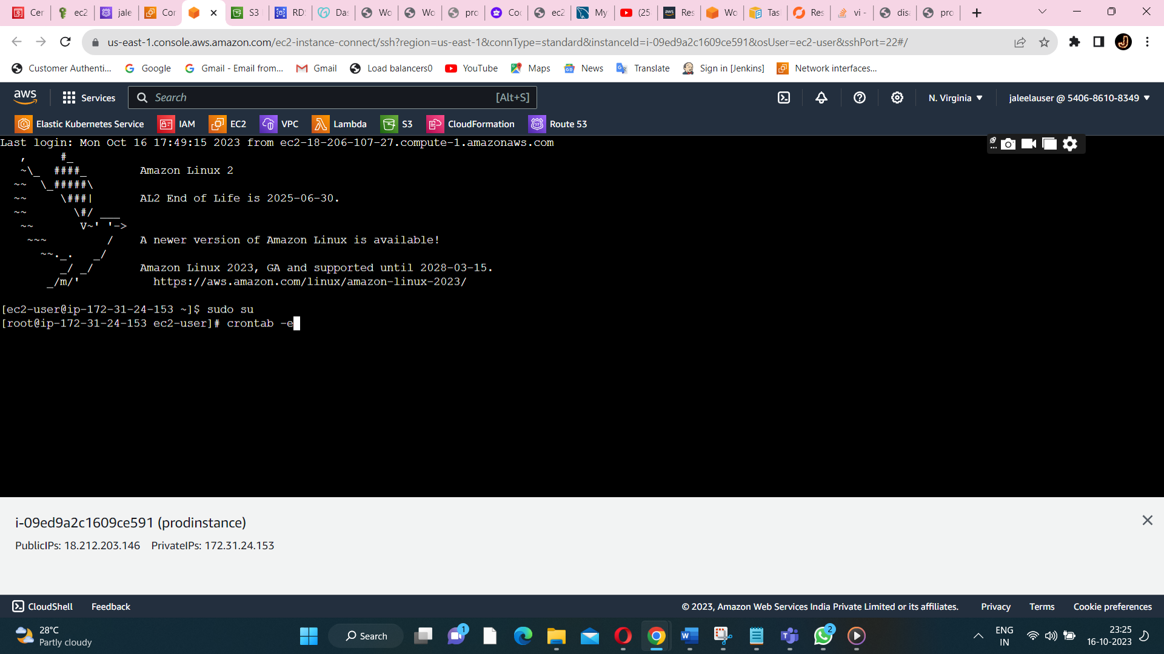

**Crontab -e is used to write a scheduling job’s occurred in a s3 bucket.**

**To create a crontab file for scheduling the jobs in a s3 bucket.**

**Cd /var/www/html**

**Cd wp-content/**

**Vi crontab -e(for writing the scheduling cron tab file).**

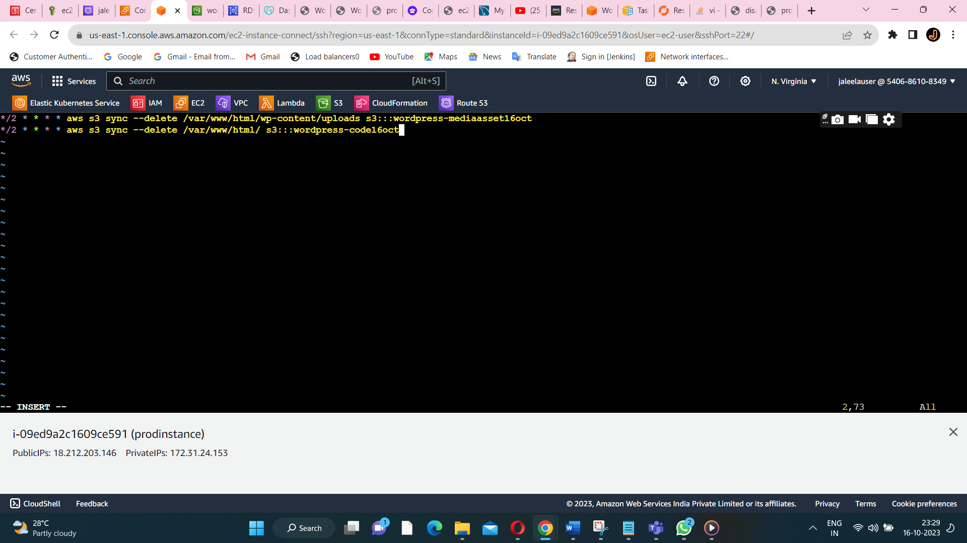

**Attach the cron-tab in aproduction server.(to get a wordpress upload content is stored in a s3 bucket).**

**\*/2 * * * * aws s3 sync --delete /var/www/html/wp-content/uploads s3:::wordpress-mediaasset16oct**

**\*/2 * * * * aws s3 sync --delete /var/www/html/ s3:::wordpress-code16oct**

**to sync with a s3 bucket.**

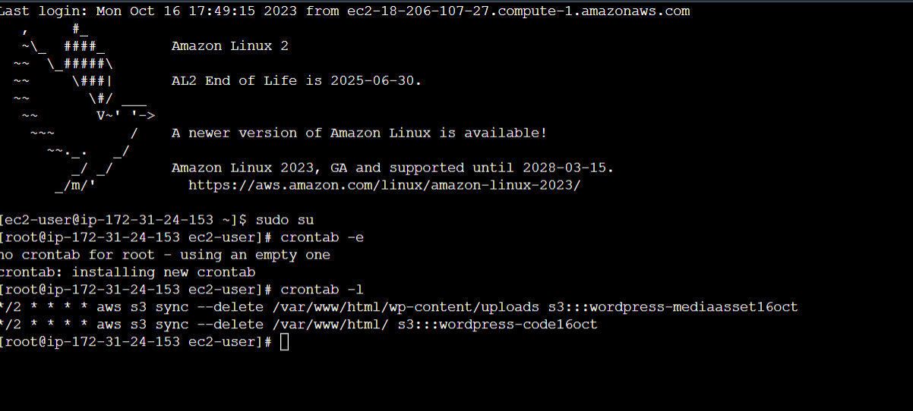

**Crontab -l is used to view the crontab jobs inside the crontab -e file.**

**Same crontab job is uploaded in a disaster server to get all the contents that is uploaded in a production server.**

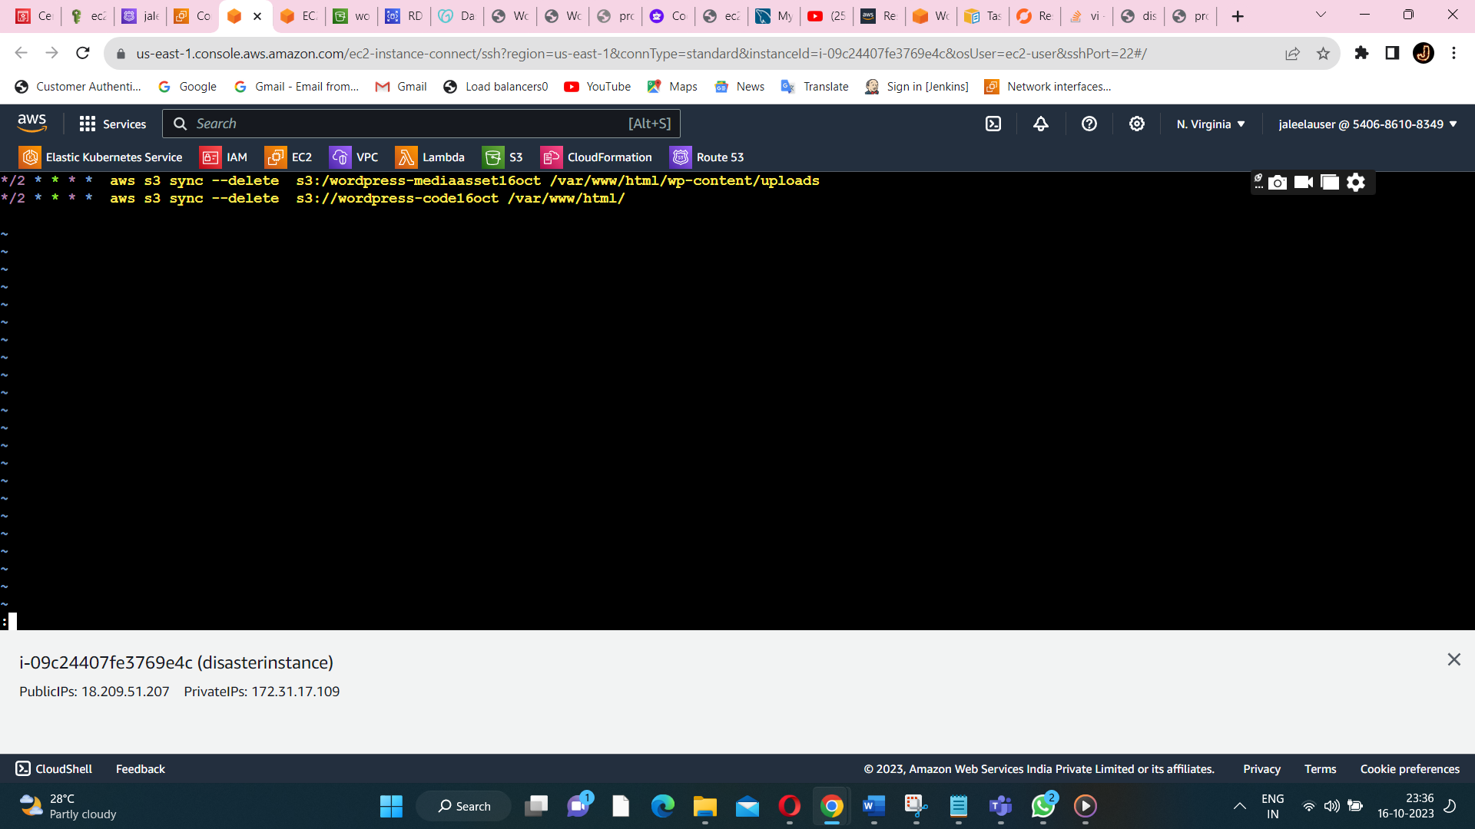

**Add the crontab jobs.**



**Is used to view the disaster path in a disaster server.**

**\*/2 * * * * aws s3 sync --delete s3://wordpress-mediaasset16oct /var/www/html/wp-content/uploads**

**\*/2 * * * * aws s3 sync --delete s3://wordpress-code16oct /var/www/html/**

**Command for disaster server(wordpress)**

**\*/2 * * * * aws s3 sync --delete /var/www/html/wp-content/uploads s3://wordpress-mediaasset16oct**

**\*/2 * * * * aws s3 sync --delete /var/www/html/ s3://wordpress-code16oct**

**Commands for production server(wordpress)**

**For to upload the content from a production server to a disaster server(to provide the replication).**

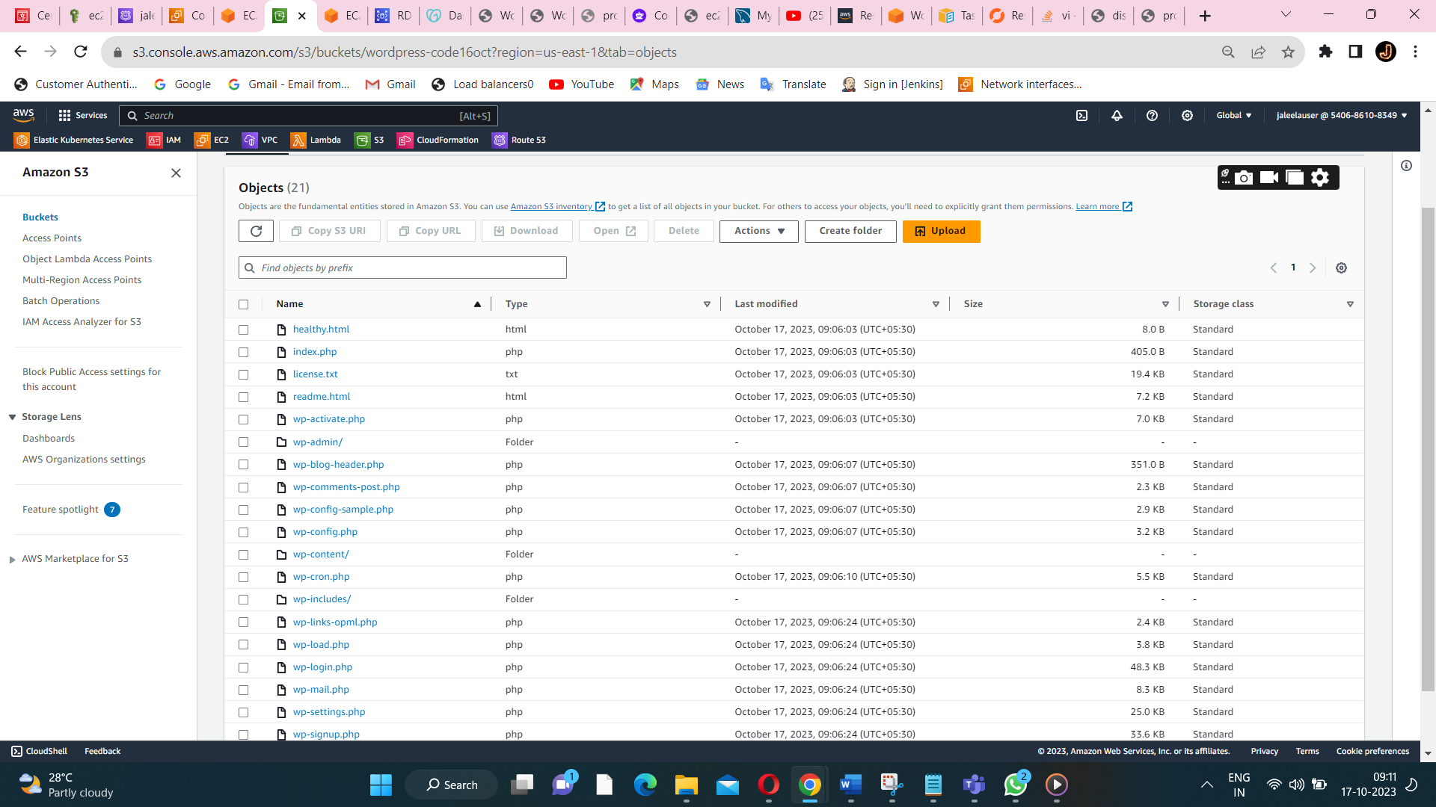

**Here after in the s3 bucket all the content get added.**

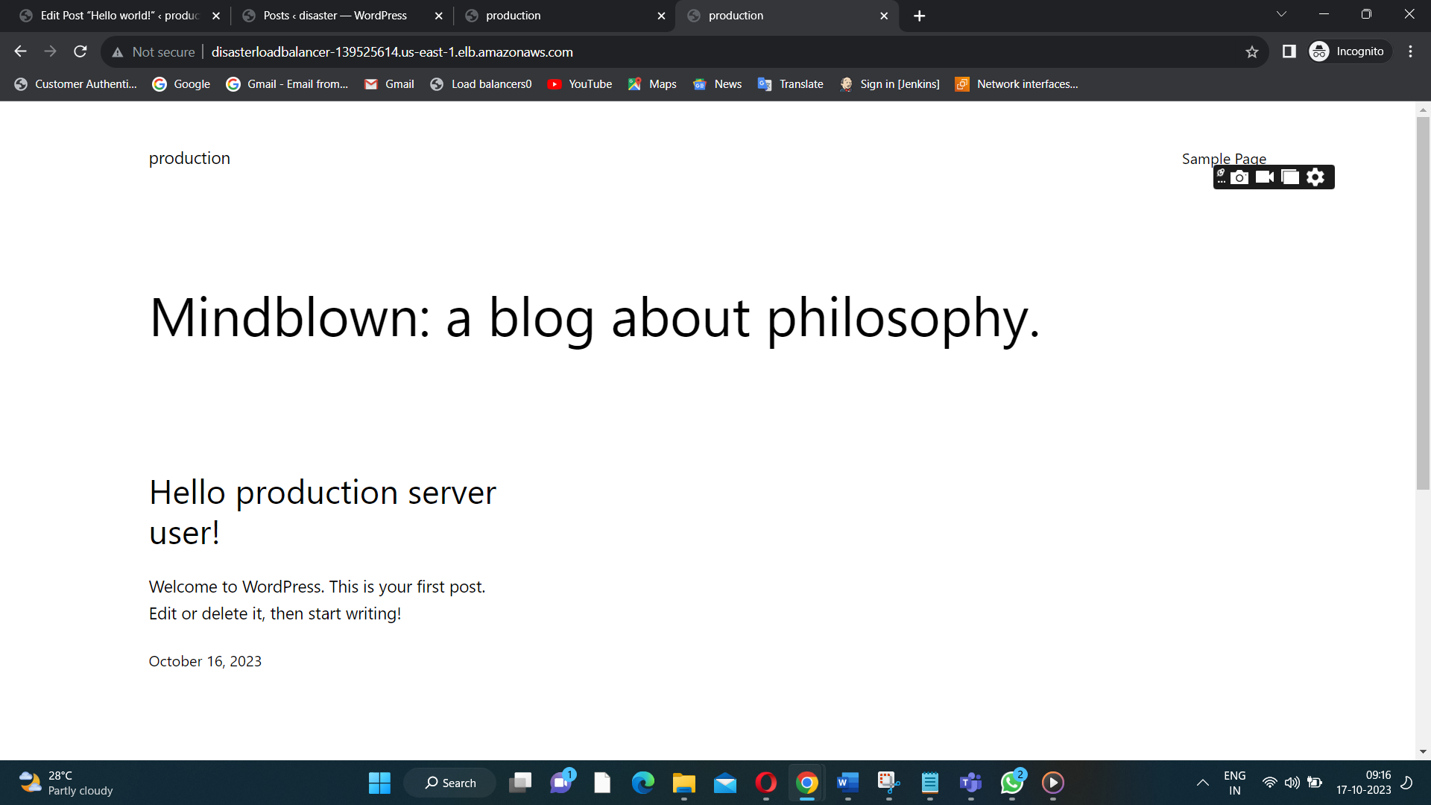

**After I load the disaster server page(I got the production server page) output.**

**STEP11:To make the domain name secure to add the certificate to a loadbalancer domain name.**

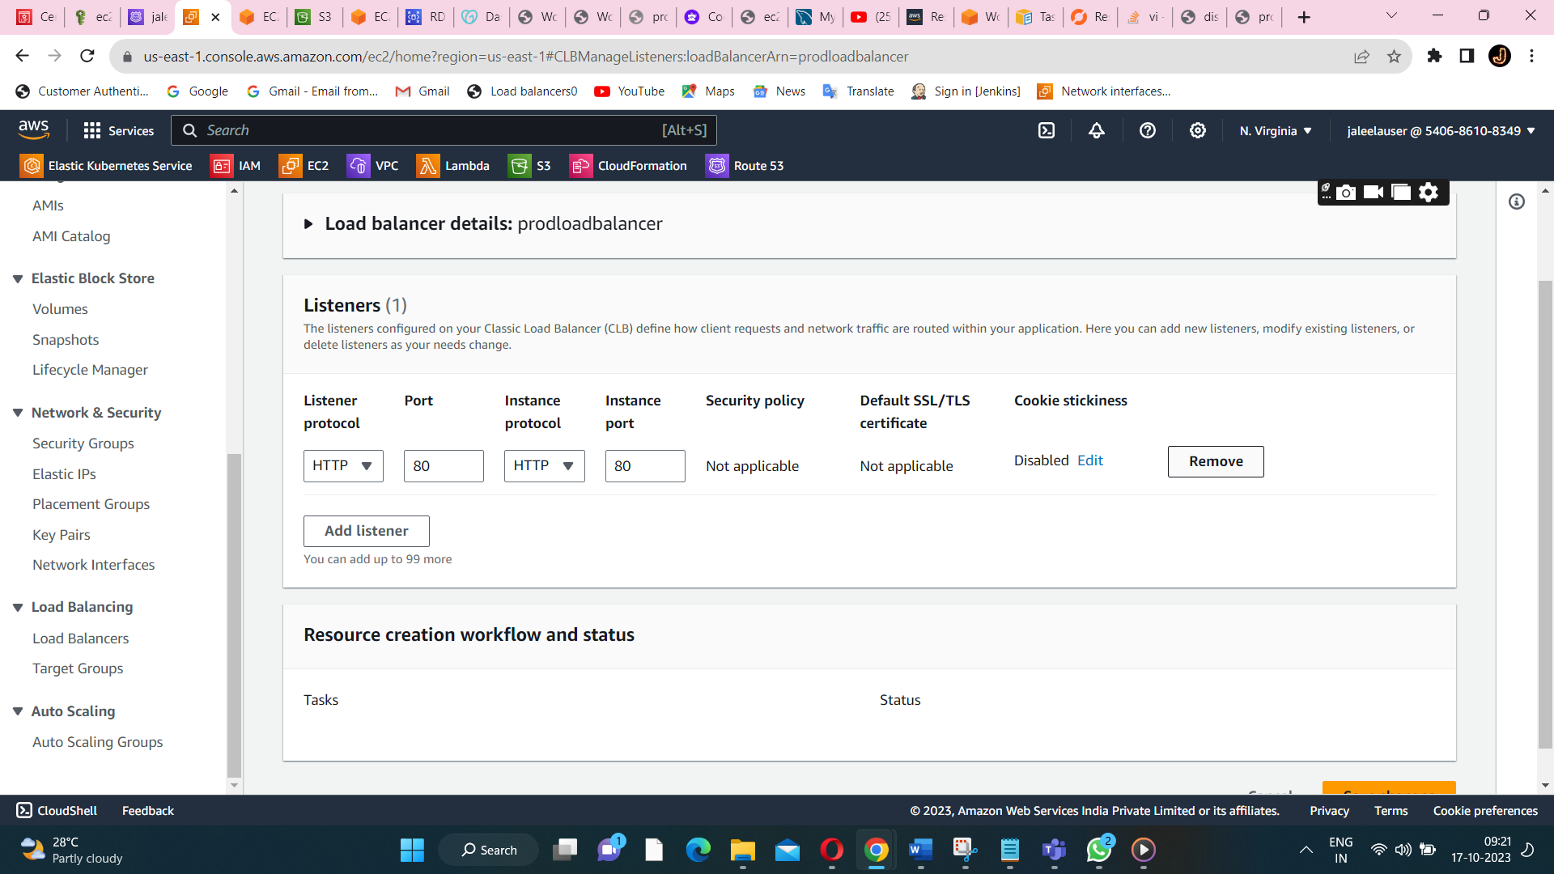

**Inside the loadbalancer listener is there(to remove the http and add https along with a certificate).**

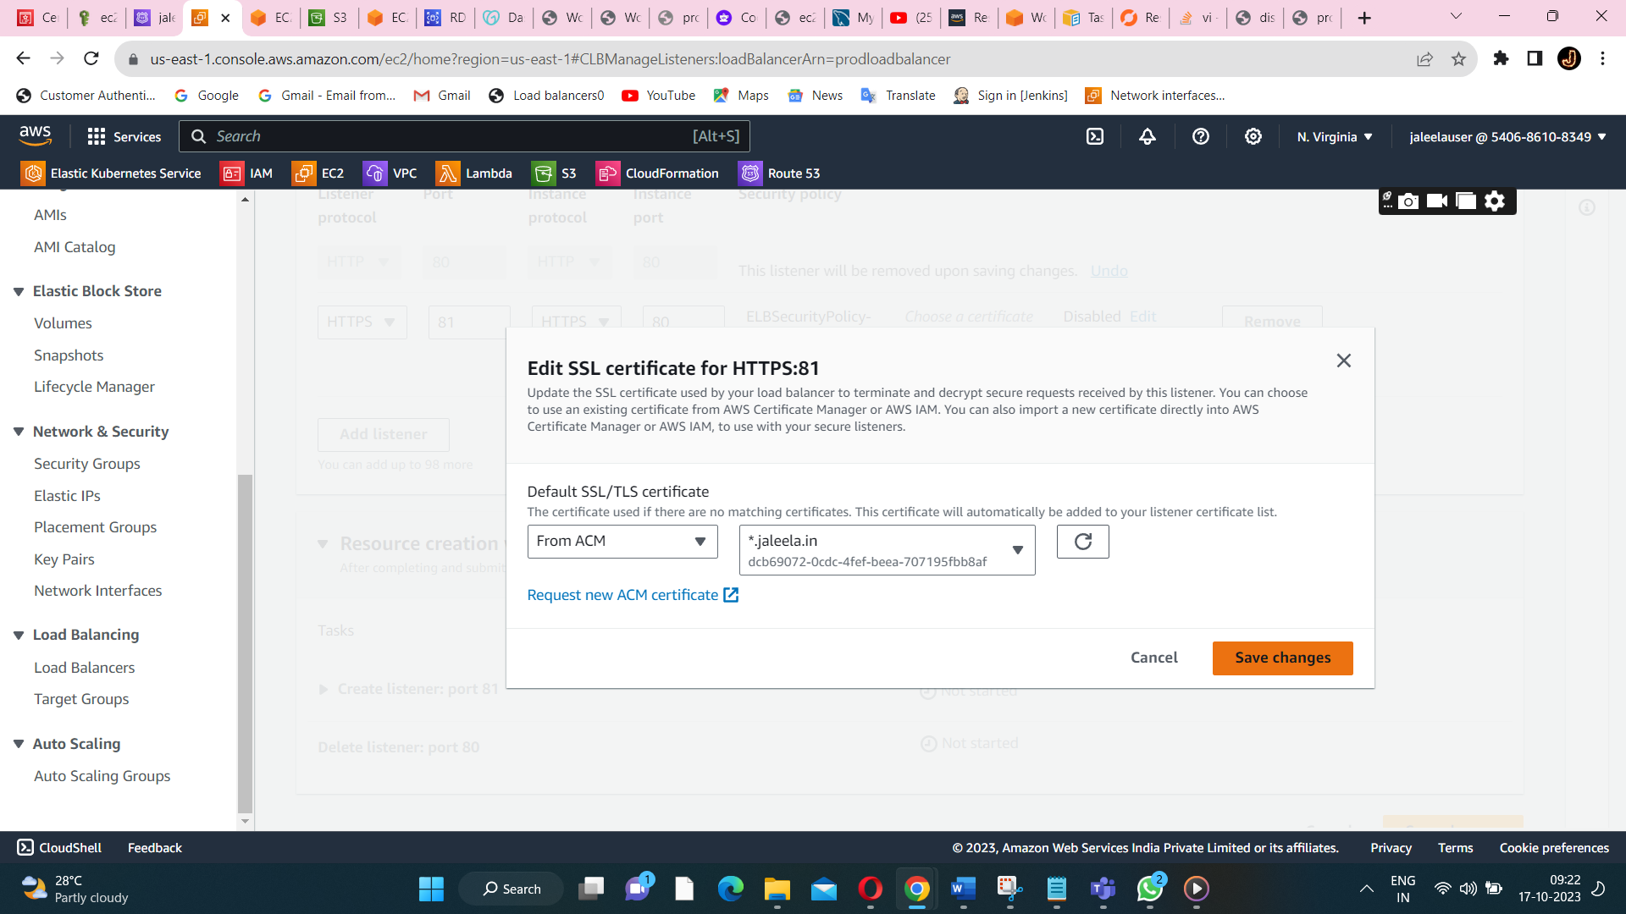

**To add the certificate from a ACM(aws certificate manager).**

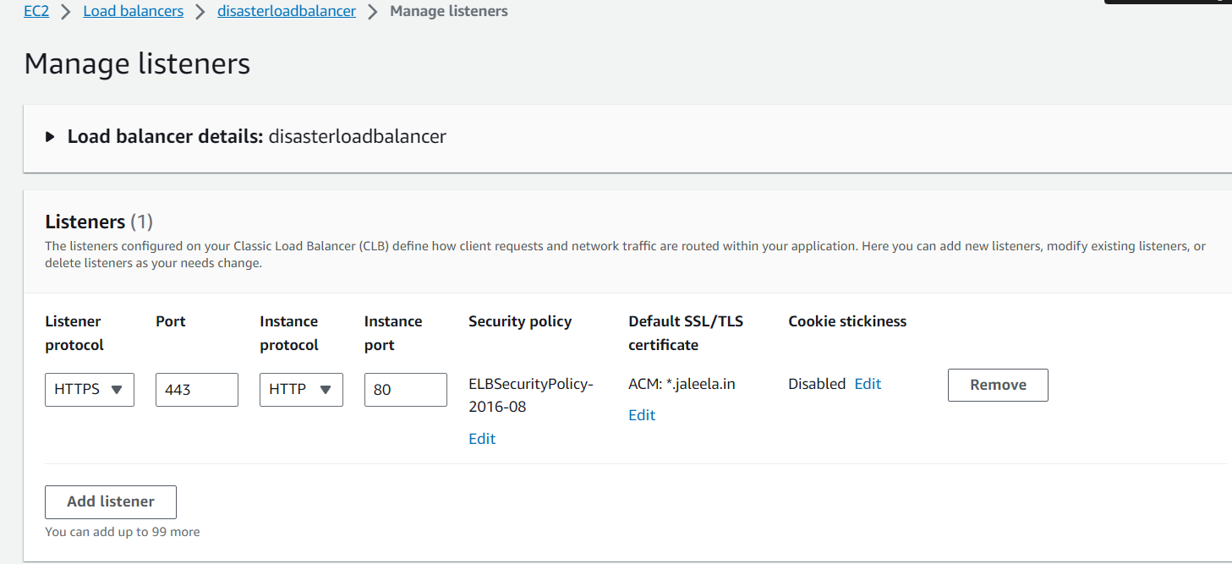

**Listener protocol should be:443 and instance protocol should be:80.**

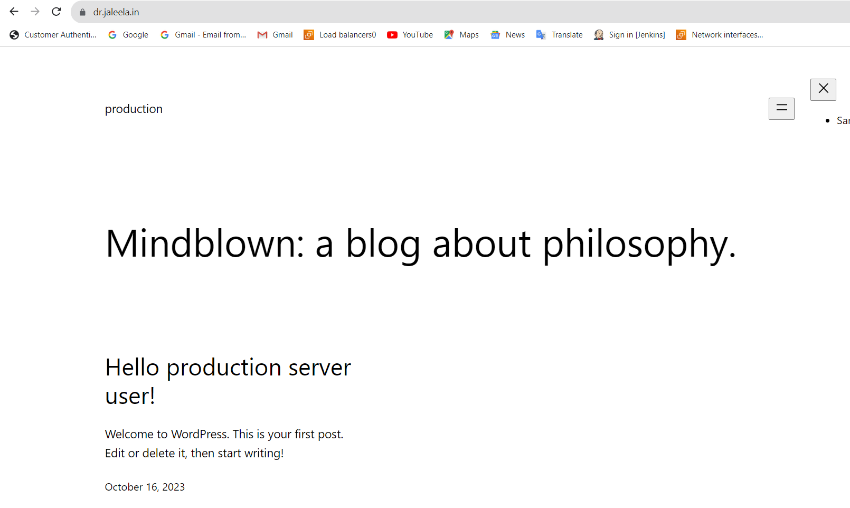

**While ping** [**https://dr.jaleela.in**](https://dr.jaleela.in) **I got the output.**

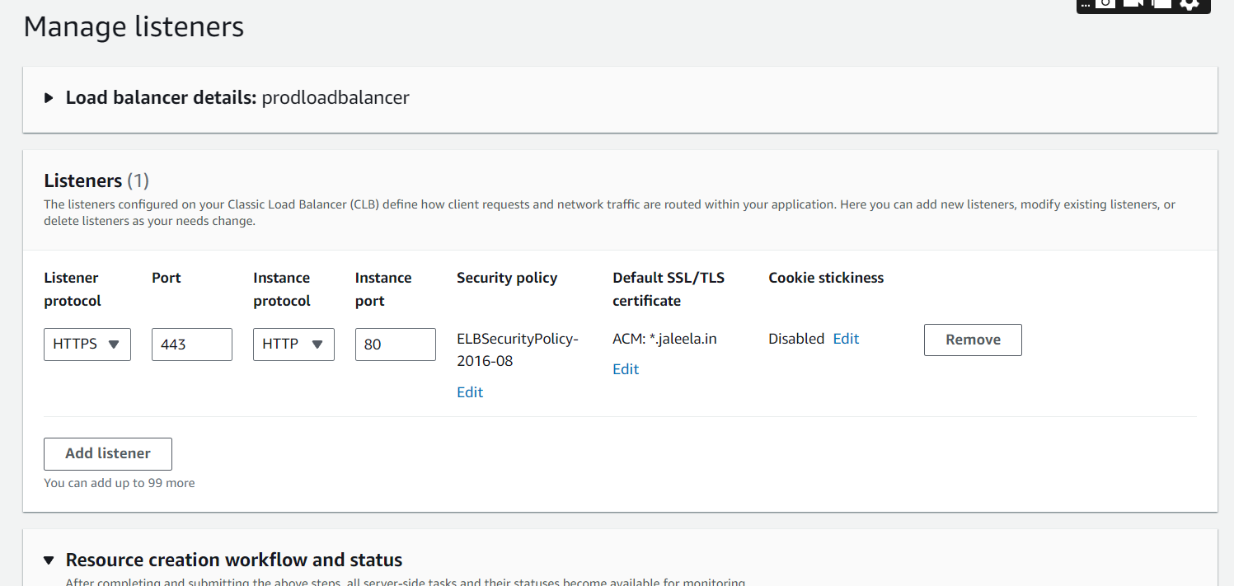

**Listener for prodloadbalancer.**

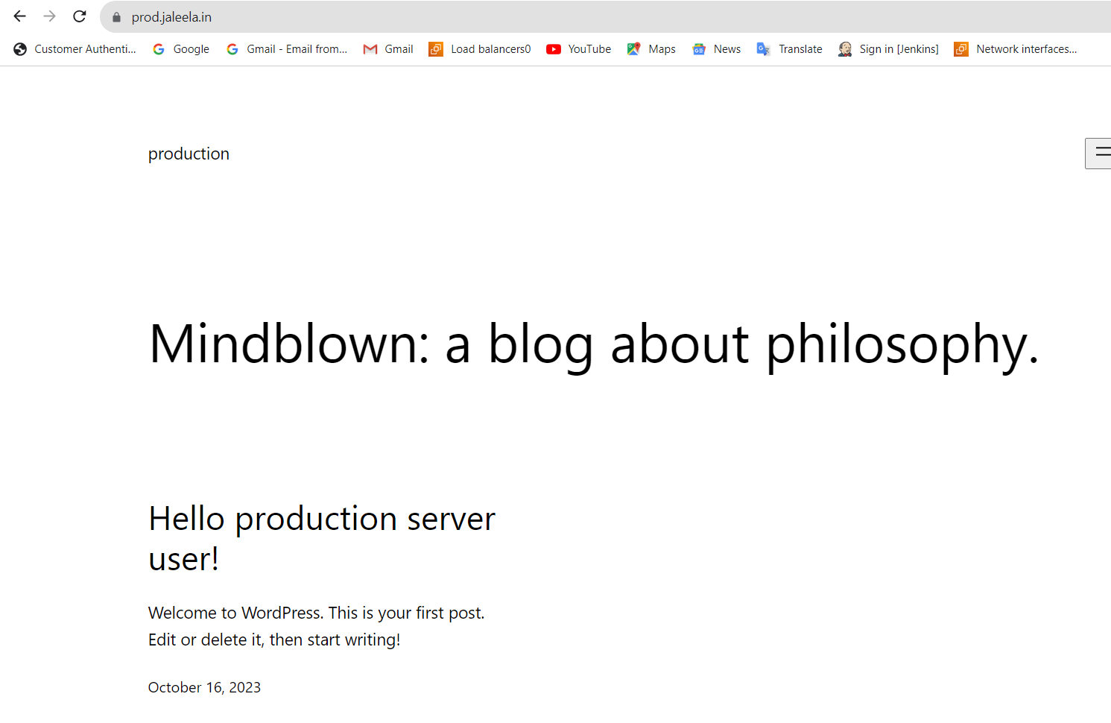

**Here,ping** [**https://prod.jaleela.in**](https://prod.jaleela.in) **got the output.**

**Here,we successfully executed the secured website launching.**